Applied General Assignment Brief
Unit 5: Investigating Science
Qualification title | Level 3 certificate and extended certificate in applied science
Unit code | ASC5 ( F/507/6501)
Unit title | Investigating Science

Learner name
Tutor/Assessor name
Assignment Title | Investigating Fermentation in the Brewing Industry
Date assignment issued |  | Submission Date

Performance Criteria
 | Pass | Merit | Distinction
Performance Outcome 1 | P1 | M1 | D1
 | P2 | M2 | D2
Performance Outcome 2 | P3 | M3
 | P4
 | P5 | M4 | D3
Performance Outcome 3 | P6 | M5 | D4
 | P7 | M6
 | P8 | M7 | D5
Performance Outcome 4 | P9 | M8 | D6
 | P10 | M9

Tasks | Performance criteria covered
Task 1a | P1,M1,D1 (8 hours)
Task 1b | P2,M2,D2 (8 hours)
Task 2 | P3,P4,P5,M3,M4,D3 (14 hours)
Task 3 | P6,P7,P8,M5,M6,M7,D4,D5 (14 hours)
Task 4 | P9,P10,M8,M9,D6 (16 hours)

Submission Checklist (please insert the items the learner should hand in) | Confirm submission
Evidence of research outlining the science behind the investigation (P1) and explaining the scientific principles (M1).
Evidence of a detailed account of the scientific principles and their relationship to commercial and industrial uses (D1).
Evidence of a plan which includes: standard procedures/techniques and the aims of individual tasks (P2) details of trials and subsequent changes made to plan (M2).
Justification of the techniques chosen and accuracy, reliability and validity shown (D2).
Evidence of carrying out the investigation: (In the risk assessment/observation record/body of the report – method and procedures)
Risk assessment (P3) with an explanation of the control measures (M3)
Observation record demonstrating that the standard procedures are correctly and safely followed (P4)
Evidence of recorded data (in the body of the report-results )
- tables for quantitative data and suitable formats for qualitative data; correct conventions and units (P5)
- assessment of effectiveness of methods to collect data (M4)
- justified suggestions for improvement (D3)
Evidence of analysing results, drawing conclusions and evaluating the investigation (in the body of the report- analysis)
- analysing (P6) and manipulating (M5) the data including use of IT (M5)
- identifying (P7) and explaining together with suggesting how they could be minimised (M6) errors/anomalous data
- give evidence to show any conclusions drawn from the data (P8) and review the use of any primary and secondary data used (M7)
- evaluating investigation outcomes (D5) justifying the methods and formats used to analyse the data (D4)
Evidence of presenting the findings of the investigation to a suitable audience(in the body of the report and the presentation summary)
- producing a report and making a presentation to a suitable audience including results and a conclusion which are clear and concise (P9) and referencing using Harvard Reference System (P10)
- referring to secondary data and using correct terminology (M8) and evaluating the sources, their usefulness and validity (M9)
Evidence of identifying the relevance of the investigation and results to appropriate industrial processes (D6).
Learner - please confirm that you have proofread your submission

Learner Authentication
I confirm that the work and/or the evidence I have submitted for this assignment is my own. I have referenced any sources in my evidence (such as websites, text books). I understand that if I don’t do this, it will be considered as a deliberate deception and action will be taken.
Learner Signature Date
Tutor declaration
I confirm the learner’s work was conducted independently and under the conditions laid out by the specification. I have authenticated the learner’s work and am satisfied that the work produced is solely that of the learner.
Tutor/Assessor Signature* Date
*Please record any assistance given to the learner beyond the group as a whole even if within the parameters of the specification

For marking purposes only

Marking grid

Performance Criteria (PC) Achieved |  |  |  |  |  |  |  |  | 1stsub* | Resub*
Pass | 1st sub*  / X** | Resub*  / X** | Merit*** | 1st sub*  / X** | Resub*  / X** | Distinction*** | 1st sub*  / X** | Resub*  / X** | Number of PCs achieved | Number  of PCs achieved
P1 |  |  | M1 |  |  | D1
P2 |  |  | M2 |  |  | D2
P3 |  |  | M3
P4
P5 |  |  | M4 |  |  | D3
P6 |  |  | M5 |  |  | D4
P7 |  |  | M6
P8 |  |  | M7 |  |  | D5
P9 |  |  | M8 |  |  | D6
P10 |  |  | M9
Total PCs achieved:

* Sub= submission and Re-sub=Re-submission (Re-submission column to be completed only if the learner has re-submitted the assignment.
** Achieved ( ) Not achieved (X). Please tick or cross for each performance criteria (PC)
*** Distinction and Merit criteria can be achieved only where the associated Merit and Pass criteria have been achieved first.

Tutor summative feedback for learner
(Note to tutors: this section should focus on what the learner has done well. Where a learner has not achieved a specific performance criterion or is likely to want to improve on a response to a performance criterion, then you may identify the issues related to the criterion, but should not provide explicit instructions on how the learner can improve their work to achieve the outstanding criteria.)*
Feedback

Tutor name(print) and date

Resubmission Feedback

Tutor name(print) and date

* All tutor notes should be deleted before the template is used.

Scenario:

As a laboratory technician working for an established microbrewery, you have been tasked with investigating the factors that affect fermentation with a view to developing and improving the brewing technique for new varieties of beers.

NB A microbrewery or craft brewery produces smaller amounts of beer in comparison with large-scale corporate breweries and is independently owned. These breweries place an emphasis on quality, flavour and brewing technique.

Within this assignment you will research, plan, investigate, draw conclusions and report on your findings. The reporting will involve a written report and an audience presentation.

Task Overview

When carrying out and reporting on laboratory investigations you should follow standard procedures and write reports. The presentations produced may take various forms (Word documents, booklet/leaflet, magazine article, webpage, PowerPoints). Laboratory work requires completed risk assessments and confirmation of the correct use of techniques undertaken (observation record, together with video/photographic evidence if appropriate), and full written records of the SPs followed and the individual learner’s recorded results that these SPs produce.

Notes:
Learners will carry out an original, extended practical investigation that draws together their knowledge, skills and understanding developed in other units.

Learners should carry out their chosen scientific investigation independently and record their own results. However .....
It may be appropriate for wide-ranging investigations where, for instance, multiple factors are investigated, for some work to be carried out in pairs or small groups with combination of results, but it is essential that the origins of all recorded data are made clear and that each individual has played a full part in the investigation.

In the case of this fermentation based assignment, there are a number of factors that are listed in the Specification (p90) ..... “Use yeast to investigate how different substrates, temperature, pH, nutrients and a range of media can be used in brewing”. Whilst it may not be possible to cover all these factors in the timescale available for the unit, it would be expected that a minimum of three factors are investigated in order that some higher POs can be met at an appropriate level and demonstrate the learners’ investigative abilities across a number of relevant areas and approaches. In P1, M1 and D1, it would be expected that all factors are considered within the account of scientific principles.

Activities

TASK 1a

PO1: Prepare for a scientific investigation

You must research and investigate the factors that affect fermentation in brewing and their principles:
factors to be considered may include
- substrate/nutrients
- yeast type
- temperature
- pH
- aerobic/anaerobic conditions
Decide on which factor(s) to investigate
Present the evidence of your independent research and use of secondary sources giving an explanation of the investigation and an outline of the relevant scientific background in your portfolio (P1).

To achieve M1, your report should include an explanation of the scientific principles behind the factors affecting fermentation in the chosen investigation and also relating to the practical approaches suggested.

To achieve D1, you need to consider these scientific principles in detail and relate them to commercial and industrial uses, in this case the brewing industry.

NB. Data will be obtained from prior knowledge, learner/tutor discussions, research and the investigation. You must make use of the primary and secondary data in this task as part of your planning. Remember to use the Harvard Reference System to keep an account of the secondary
data used as this will be required for your final report.

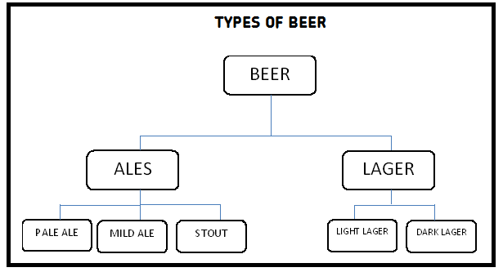

TASK 1b:

PO1: Prepare for a scientific investigation

Before starting your investigation you must produce a plan. This must include the overall purpose of the investigation, details and aims of individual practical tasks (researched standard procedures / practical techniques), together with details of observations or measurements to be made (P2). It is important that the plan includes reference to experimental techniques that may be used and which would generate relevant data that is accurate and reliable. Examples may include techniques to measure rate of fermentation (eg by measuring rate of production of carbon dioxide) and the concentration of ethanol formed (eg via specific gravity measurements).

For (M2) you should record details of trials completed and any modifications consequently made to the plan and researched procedures described.

[Note that the trials should be such that they enable SPs to be modified in order to improve accuracy, precision of data/recording and reliability/repeatability of data]

For (D2) justify the techniques/procedures used in terms of accuracy, validity, reliability and the precision of recorded data obtained. (See Glossary for definitions). This would include, for instance, a justification of the technique chosen to measure the volume of gas evolved against time ie choosing the best, most accurate method for this Level 3 investigation and not a simple, low-level inherently inaccurate approach.
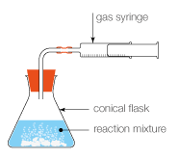
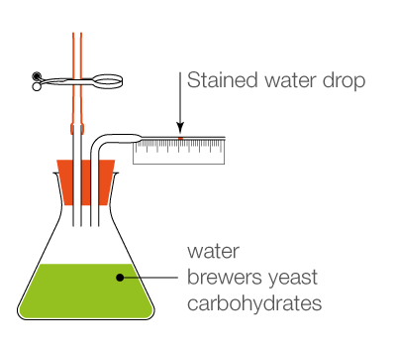

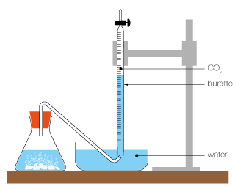

TASK 2:

PO2 Carry out the investigation and record results
Before any practical work is started, you should complete a risk assessment. This will make you aware of any hazards and risks that are associated with the practical work you are about to do (P3). Standard procedures, modified from the results of the trials previously carried out, should then be followed correctly to ensure that equipment and materials are used safely (P4).This should be supported with an observation statement/record completed by the assessor and may be accompanied by video/photographic evidence if deemed appropriate. All SPs must be included in the portfolio and the recorded results should entirely support the other evidence.

The merit (M3) will be completed if, in addition to (P3), the control measures identified in the risk assessment are explained.

Learners should prepare their own tables, using correct conventions, and record their results in appropriate formats (qualitative) and with a suitable level of precision (ie correct number of significant figures ) and use of correct units (quantitative) (P5).

Type of data | Suggested observations/data
Qualitative data | Colour | Smell | Clarity
Quantitative data | Rate of CO₂ production | Ethanol content (final and over time). | Clarity (colorimetric approach)

To achieve the higher grades, the effectiveness of the data collection methods should be assessed (for instance in terms of its accuracy, reliability and levels of precision) (M4) and suggestions for improvements to the methods and/or apparatus used justified (D3).

TASK 3: Analyse results, draw conclusions and evaluate the investigation

After obtaining your results, these must be analysed using appropriate methods eg use of appropriate calculations, graphs and charts (P6).

For the merit, data must be manipulated using appropriate calculations and IT packages (M5) and, for the Distinction, the methods and formats used must be justified (D4). Sources of error and any anomalous data must be identified (P7) and the merit will require error sources and reasons for anomalous data to be explained, together with suggestions for their minimalisation (M6).

Conclusions drawn from the data obtained during the investigations will achieve the pass (P8). By comparing the conclusions drawn from the investigation (primary data) with information gained from seconadary sources during planning, the merit (M7) will be achieved. An evaluation of the outcomes of the investigation will achieve the (D5). This will include a systematic consideration of qualitative and quantitative errors including, if relevant, percentage errors.

TASK 4: Present the findings of the investigation to a suitable audience

Learners should produce a report on their scientific investigation which should include an introduction, risk assessment, method and procedures, details of trials and any modifications of procedures, results, analysis, conclusion and bibliography. They should also make a presentation, combining text and images, to a suitable audience and include a record of that presentation (P9).
The merit will be achieved if correct scientific terminology is used throughout the report and presentation and there is reference to secondary data (M8).
By identifying the relevance of the investigation and the results obtained to appropriate industrial processes (linking to D1), the distinction (D6) will be achieved.

Information sources used for research and for supporting conclusions are recorded using the Harvard Reference System (P10) and are evaluated in terms of usefulness and validity (ie validation) (M9).

Useful Links

Nuffield foundation – Scientific investigations – getting started
Alcohol uses
Ways alcohol can be used
Products from alcohol
Simple statistical analysis
Harvard referencing
Top tips for effective presentions

Technical Notes

These will be dependent on the actual procedures/techniques used by individuals but could include:
- specialist or DIY fermenters
- various glassware
- different varieties/strains of yeasts
- hydrometers
- thermometers
- pH meters
- various substrates/nutrients

