ELC Science

Component 3 – Chemistry: Elements, mixtures and compounds (Outcome 3)
Teacher Devised Assignment: Student writing frame

Component | Skill Area A | Skill Area B | Skill Area C | Skill Area D | Skill Area E | Total mark
3 | 1/2/3 | 1/2/3 | 1/2/3 | 1/2/3 | 1/2/3 | /15

Investigative activity: Which substance has the highest melting point?

Information

- When a substance melts to become a liquid, the particles are able to move about but stay close together.
- Substances with high melting points have strong forces that hold their particles closer together. Substances with low boiling points have weak forces between their particles.

What am I trying to find out?

Skill Area A: Planning
Entry Level 1

Tick () which items of equipment you will need from the list below:

kettle |  | beeswax polish |  | laboratory stand and clamp
beaker |  | thermometer |  | butter
balance 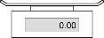 |  | marker pen |  | 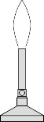  Bunsen burner
candle wax |  | heating gauze |  | 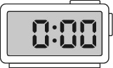  stop watch
tripod |  | margarine |  | boiling tube
wooden splint |  | spatula |  | measuring cylinder

Any other equipment needed?

No / Yes ……………………………………………………………………………………………….………

How will I set up the apparatus?: Draw diagram here

Planning Skill Area A: Entry Level 2 `
What I’m going to do: This can be bullet points or a flow chart
………………………………………………………………………………………………………………………………………………………………………………………………………………………………
………………………………………………………………………………………………………………
………………………………………………………………………………………………………………
………………………………………………………………………………………………………………
………………………………………………………………………………………………………………
………………………………………………………………………………………………………………
………………………………………………………………………………………………………………
………………………………………………………………………………………………………………
………………………………………………………………………………………………………………
………………………………………………………………………………………………………………
………………………………………………………………………………………………………………

To make it a fair test,
I am going to keep these things the same:
……………………………………………………………………………

I am only going to change
…………………………………………………………………………………………………………………

I am going to measure …………………………………………… using …………………………

Planning Skill Area A: Entry Level 3

What I think might happen
I think the substances with the highest melting points will be ……………………………………………………………………............................................................
…………………………………………………………………………………………………………… because ………………………………………………………………………………………………………………………………………………………………………………………………………………………………………………………………………………………………………………………………………………
…………………………………………………………………………………………………….………
………………………………………………………………………………………………………………………………………………………………………………………………………………………………………………………………………………………………………………………………………………

Skill Area B: Doing
Entry level 1 and 2
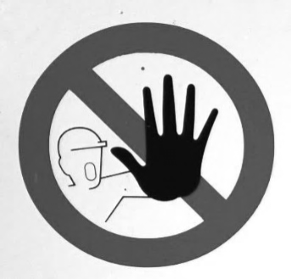
Skill Area B – Level 3
I have used the equipment in an organised and safe way to get my results
I worked safely

I can trust my results because ……………………………………………………….…………………..................................................
……………………………………………………………………………………………………………….
………………………………………………………………………………………………………………….………………………………………………………………………………………………………………….…………………………………………………………………………………………………………
………………………………………………………………………………………………………………

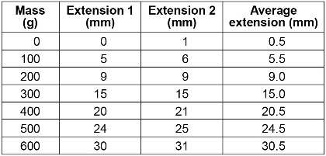
Skill Area C: Recording data (my observations)

Entry levels 1, 2 and 3

My results:
Think carefully about your variables and units – (what you are measuring?)

Skill Area D: Processing and presenting data
Showing patterns in my results
Entry levels 1, 2 and 3
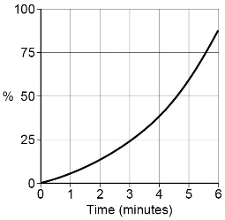
I am going to use a: bar chart 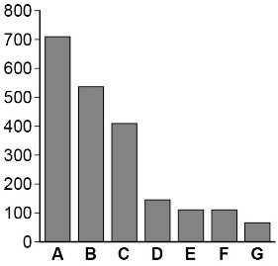

line graph to show the results I collected
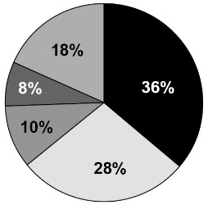

pie chart

other

Show or attach your processed data here:

Skill Area E: Interpreting and Evaluating
Levels 1, 2 and 3
Conclusion: My evidence tells me that the substances with the highest melting point are:
…………………..…………………………………………………………………………………………..
………………………………………………………………………………………………………………
…………………………………………………………………………………………………………….….
………………………………………………………………………………………………………………..
My evidence shows this because (describe any patterns or trends in your results) ……………………………………………………………………………………………………..…………
………………………………………………………………………………………………………..………
………………………………………………………………………………………………………………..
………………………………………………………………………………………………………………
………………………………………………………………………………………………..………………
………………………………………………………………………………………………………..………
…………………………………………………………………………………………………………..……
………………………………………………………………………………………………………..………
…………………………………………………………………………………………………………..……

Skill Area E: Evaluating
Level 3 only

How does my evidence match my prediction?
………………………………………………………………………………………………………………
……………………………………………………………………………………………………….………
………………………………………………………………………………………………………………
………………………………………………………………………………………………………………
Could I make my evidence even better? Explain how you could improve what you did
………………………………………………………………………………………………………………
………………………………………………………………………………………………………………
………………………………………………………………………………………………………………
………………………………………………………………………………………………………………
………………………………………………………………………………………………………………

