Applied General Assignment Brief
(Unit 2 Biology)
Qualification title | Level 3 certificate and extended certificate in applied science
Unit code | L/507/6498
Unit title | Unit 2 Applied experimental techniques (Biology)

Learner name
Tutor/Assessor name
Assignment Title | Measuring respiration and photosynthesis
Date assignment issued |  | Submission Date

Performance Criteria
 | Pass | Merit | Distinction
Performance Outcome | P1 | M1 | D1
 | P2 | M2 | D2
 | P3 | M3
 | P10

Tasks | Performance criteria covered
Task 1 (Approximately 7 hrs) | P1, M1, D1,
Task 2 (Approximately 6 hrs) | P2, M2, D2 and P 10
Task 3 (Approximately 7 hrs) | P3, M3 and P10

Submission Checklist (please insert the items the learner should hand in) | Confirm submission
Evidence of a report outlining the physiological measurements (P1) and explaining the basic scientific principles associated with them (M1)
Evidence of a report explaining the uses and application of physiological measurements in medical or commercial context (D1)
Evidence of a report for rate of respiration including:
- standard procedure followed (P2)
- using formulas, calculations and graphical representation to explain the data (M2)
Evidence of a report evaluating the results and methods used for measuring rate of respiration (D2)
Evidence of a report for Hill reaction including standard procedure followed and results recorded accurately (P3)
Evidence of a report explaining how the standard procedure could be adapted to investigate three limiting factors (M3)
Evidence of two risk assessments for each technique, of which one must be carried out by you (P10)
Witness confirmation form completed for these techniques by the tutor
Learner - please confirm that you have proofread your submission

Learner Authentication
I confirm that the work and/or the evidence I have submitted for this assignment is my own. I have referenced any sources in my evidence (such as websites, text books). I understand that if I don’t do this, it will be considered as a deliberate deception and action will be taken.
Learner Signature Date
Tutor declaration
I confirm the learner’s work was conducted independently and under the conditions laid out by the specification. I have authenticated the learner’s work and am satisfied that the work produced is solely that of the learner.
Tutor/Assessor Signature* Date
*Please record any assistance given to the learner beyond the group as a whole even if within the parameters of the specification

For marking purposes only

Marking grid

Performance Criteria (PC) Achieved |  |  |  |  |  |  |  |  | 1stsub* | Resub*
Pass | 1st sub*  / X** | Resub*  / X** | Merit*** | 1st sub*  / X** | Resub*  / X** | Distinction*** | 1st sub*  / X** | Resub*  / X** | Number of PCs achieved | Number  of PCs achieved
P1 |  |  | M1 |  |  | D1
P2 |  |  | M2 |  |  | D2
P3 |  |  | M3
P10 |  | P10 to be graded only once on the unit submission form
Total PCs achieved:

* Sub= submission and Re-sub=Re-submission (Re-submission column to be completed only if the learner has re-submitted the assignment.
** Achieved ( ) Not achieved (X). Please tick or cross for each performance criteria (PC)
*** Distinction and Merit criteria can be achieved only where the associated Merit and Pass criteria have been achieved first.

Tutor summative feedback for learner
(Note to tutors: this section should focus on what the learner has done well. Where a learner has not achieved a specific performance criterion or is likely to want to improve on a response to a performance criterion, then you may identify the issues related to the criterion, but should not provide explicit instructions on how the learner can improve their work to achieve the outstanding criteria.)*
Feedback

Tutor name(print) and date

Resubmission Feedback

Tutor name(print) and date

* All tutor notes should be deleted before the template is used.

Scenario

Measuring respiration and photosynthesis
As a student on a one-year industrial placement working for a multinational life sciences company, you are involved in working with human/animal and plant physiology departments.
Within this assignment you will research, investigate and report on two of the most significant and interrelated processes essential to all organisms, namely respiration and photosynthesis.
Task overview
Consideration should be given to why and how the physiological measurements of these two processes may be used and applied in commercial or medical situations, such as:
- by sports scientists or the medical professions
- agricultural, manufacturing, food industries

When carrying out laboratory investigations, standard procedures should be followed and results recorded. The Witness Confirmation sheet should indicate that you have carried out both physiological investigations. Records should include a full account of the standard procedure, results obtained, relevant tabulated results with calculations, and graphs as appropriate.
In addition to the above:
- the resulting evidence should be analysed textually, visually (diagrams/photographs), mathematically and graphically as appropriate
- procedures should be evaluated in terms of the methods used and the results produced
- an adaptation of the Hill reaction to investigate the effect of limiting factors should be noted.

Activities
Task 1
PO1 Demonstrate applied experimental techniques in biology
Prior to carrying out any physiological technique for a commercial or medical purpose, it is important to establish and report on the physiological measurements used in relation to rate of respiration (production of CO₂ and uptake of O₂, peak flow, lung capacity) and photosynthesis (production of O₂ and uptake of CO₂) (P1).
To achieve M1, your report should include an explanation of the scientific principles of the physiological measurements used in relation to respiration and photosynthesis:
- peak flow, lung capacity, blood pressure (heart rate and breathing rate)
- factors affecting respiration rate in humans
- factors affecting respiration rate, CO₂ production and O₂ uptake in non-humans
- metabolic rates at rest, during exercise and in different temperature situations
- rate of carbon dioxide consumption in plants during photosynthesis
- rate of photosynthesis and the effect of limiting factors such as light, CO₂ availability, temperature, chlorophyll availability, use of herbicides.
To achieve D1, you need to consider how these physiological measurements can be applied in a medical or commercial situation.

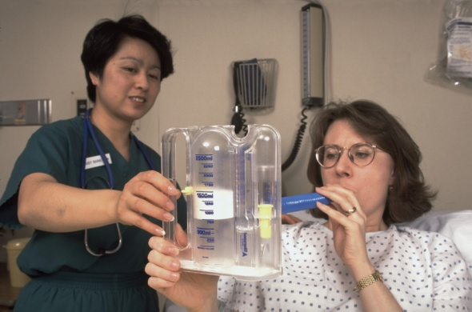
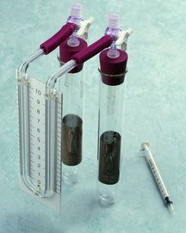

Task 2
PO1 (a) Rate of respiration
PO4 Understand safety procedure and risk assessment when undertaking scientific practical work
Before any practical work is started, you should complete a risk assessment. This will make you aware of any risks or hazards that are associated with the practical work you are about to do (P10).
Follow a standard procedure to measure the effect of varying one given factor on the rate of respiration of a living organism (P2).
Choose one of the following:
- the effect of temperature on CO₂ production by yeast or invertebrates such as woodlice or maggots (e.g http://www.nuffieldfoundation.org/practical-biology/measuring-rate-metabolism)
- the effect of oxygen consumption by germinating seeds. (e.g.http://www.biologyjunction.com/respiration%20of%20germinating%20seeds.pdf)

Ensure that:
- the procedure is fully risk-assessed and a risk assessment is produced
- any invertebrates (eg woodlice, maggots) used are treated ethically, with care and respect
- the procedure is strictly adhered to so that a fair replication of the results could be undertaken
- results are correctly recorded, tabulated and with regard for correct precision and units

You should include the standard procedure followed in your report for this technique (P2).

On completion of the practical work, you should ensure that you have used formulas, calculations and graphical representations to explain data and the calculated rate of respiration and the effect of the variable selected (M2).
In addition, for D2, you need to evaluate the results and the practical methods used, considering the precision, reliability and accuracy of the recorded data.
Task 3
PO1 (b) The light-dependent reaction in photosynthesis (the Hill reaction)
PO4 Understand safety procedure and risk assessment when undertaking scientific practical work
Before any practical work is started, you should complete a risk assessment. This will make you aware of any risks or hazards that are associated with the practical work you are about to do (P10).
Safety sheets
science.cleapss.org.uk/Resource-Info/Student-Safety-Sheets-ALL.aspx
Follow a standard procedure to measure the light-dependent reaction in photosynthesis (the Hill reaction) (P3). (e.g http://www.nuffieldfoundation.org/practical-biology/investigating-light-dependent-reaction-photosynthesis)
This measures the first stage of photosynthesis, the light-dependent reaction. The procedure requires experimenters to work quickly, and everything needs to be kept cool. For these reasons, it may be appropriate to work collaboratively with other learners. Fresh green spinach, lettuce or cabbages are all suitable materials to use.
Ensure that:
- the procedure is fully risk assessed and a risk assessment is produced
- the procedure is strictly adhered to so that a fair replication of the results could be undertaken
- results are correctly recorded

You should include the standard procedure followed in your report for this technique (P3).

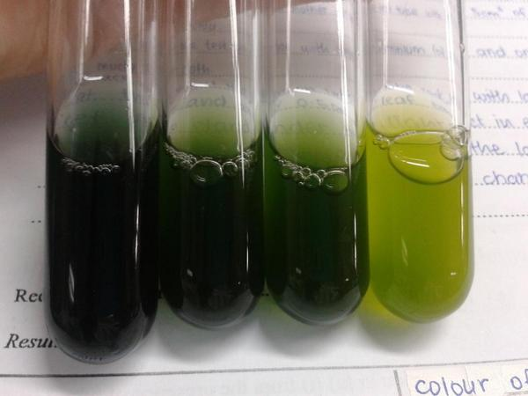
On completion of the practical work, you should ensure that you have explained how the standard procedure could be adapted to investigate the three relevant limiting factors (M3). (Note that they should be different to those chosen for P3). Note that this will also require a consideration of the underpinning science related to these three limiting factors.

Technical notes
Rate of respiration
Equipment needed
- respirometer ×1 (this is comprised of: two boiling tubes, one basket or cage (metal or plastic), one 1 cm³ syringe)
- two bungs (one-holed if using 3-way taps, two-holed if these are not available), and one manometer (a capillary U-tube fixed to a scale on a board and filled with coloured oil)
- potassium hydroxide solution, 15% (= 2.7 M), about 15 cm³
- funnel
- filter paper, cut into strips, to form tight rolls
- small quantity (about 5 cm³) of living material such as seeds (germinating), woodlice, Calliphora larvae or a locust.

The light-dependent reaction in photosynthesis
Equipment needed per student or group of students:
- centrifuge, with RCF between 1500 g and 1800 g
- centrifuge tubes
- fresh green spinach, lettuce or cabbage, three leaves (discard the midribs)
- scissors
- cold pestle and mortar (or blender or food mixer) which has been kept in a freezer compartment for 15–30 minutes (if left too long the extract will freeze)
- muslin or fine nylon mesh
- filter funnel
- ice-water-salt bath
- glass rod or Pasteur pipette
- measuring cylinder, 20 cm³
- beaker, 100 cm³
- pipettes, 5 cm³ and 1 cm³
- bench lamp with 100 W bulb
- test tubes ×5
- boiling tube
- pipette for 5 cm³
- pipette for 0.5 cm³
- pipette filler
- waterproof pen to label tubes
- colorimeter and tubes
- 0.05 M phosphate buffer solution, pH 7.0: store in a refrigerator at 0–4 °C (Note 1)
- isolation medium (sucrose and KCl in phosphate buffer): store in a refrigerator at 0–4 °C
(Note 2)
- potassium chloride (low hazard) (Note 3)
- DCPIP solution (low hazard) (1 × 10⁻⁴ M approx.) (Note 4).

Notes

1 0.05 M phosphate buffer solution, pH 7.0. Na₂HPO₄.12H₂O, 4.48 g (0.025 M) KH₂PO₄, 1.70 g (0.025 M). Make up to 500 cm³ with distilled water and store in a refrigerator at 0–4 °C. Low hazard.
2 Isolation medium. Sucrose 34.23 g (0.4 M) KCl 0.19 g (0.01 M). Dissolve in phosphate buffer solution (pH 7.0) at room temperature and make up to 250 cm³ with the buffer solution. Store in a refrigerator at 0–4 °C. Low hazard.
3 Potassium chloride 0.05 M. Dissolve 0.93 g in phosphate buffer solution at room temperature and make up to 250 cm³. Store in a refrigerator at 0–4 °C. Use at room temperature. (Note that potassium chloride is a cofactor for the Hill reaction.)
4 DCPIP solution. DCPIP 0.007–0.01 g, made up to 100 cm³ with phosphate buffer.

