Applied General Assignment Brief
Unit 6a: Microbiology (PO1 and PO2)
Qualification title | Level 3 certificate and extended certificate in applied science
Unit code | J/507/6502
Unit title | Microbiology

Learner name
Tutor/Assessor name
Assignment Title | Assignment 1 Microorganisms and their cultivation
Date assignment issued |  | Submission Date

Performance Criteria
 | Pass | Merit | Distinction
Performance Outcome1 | P1 | M1 | D1
 | P2 | M2
 | P3
Performance Outcome2 | P4 | M3 | D2
 | P5 | M4

Tasks | Performance criteria covered
Task1 | P1, M1 (5 hours)
Task2 | P2,P3,M2,D1 (7 hours)
Task3a | P4,P5,M3,M4,D2 (5 hours)
Task3b | P4,P5,M3,M4,D2 (5 hours)
Task3c | P4,P5,M3,M4,D2 (6 hours)

Submission Checklist (please insert the items the learner should hand in) | Confirm submission
Task 1
To achieve P6 provide evidence describing the ultrastructure of akaryotes (viruses), prokaryotes (bacteria) and eukaryotes (microscopic fungi).
To achieve the M1 provide evidence relating the characteristics of these three groups to their function. | .
Task 2
To achieve P2 provide evidence describing how Gram staining, microscopy (light and electron and colony characteristics assist in the identification of microorganisms
For the P3 supply evidence demonstrating that the correct use of Gram staining has been carried out. This should include a signed observation statement completed by the assessor and possibly visual evidence.
To achieve the M2 an explanation of how the identification techniques are related to the structure of the microorganisms e.g. the chemical nature of bacterial cell walls and their ability to react to Gram staining.
In order to obtain D1 provide evidence that compares the use of different identification techniques in biotechnological industries. . e.g. environmental monitoring of water samples, testing the antimicrobial effectiveness of medical products.
Task 3a,3b,3c
For P4 three risk assessments must be completed for three different cultivation techniques chosen from the list in task 3a,3b,3c
For the P5 supply evidence demonstrating that the three different cultivation techniques have been correctly performed using aseptic techniques. The techniques should show that at least two different organisms have been used e.g. a bacteria and a fungus. Evidence should include signed observation statement(s) completed by the assessor and possibly visual evidence.
The M3 may be achieved by explaining the control measures undertaken. The evidence for this may be identified in the appropriate risk assessment documentation or separate documentation.
Achievement of the M4 requires explanations of the principles underlying the techniques chosen e.g. the requirement of a bacterial host to cultivate viruses.
By evaluating the effectiveness of the aseptic and cultivation techniques used and making justified suggestions for improvement the D2 will be achieved.
Learner - please confirm that you have proofread your submission

Learner Authentication
I confirm that the work and/or the evidence I have submitted for this assignment is my own. I have referenced any sources in my evidence (such as websites, text books). I understand that if I don’t do this, it will be considered as a deliberate deception and action will be taken.
Learner Signature Date
Tutor declaration
I confirm the learner’s work was conducted independently and under the conditions laid out by the specification. I have authenticated the learner’s work and am satisfied that the work produced is solely that of the learner.
Tutor/Assessor Signature* Date
*Please record any assistance given to the learner beyond the group as a whole even if within the parameters of the specification

For marking purposes only

Marking grid

Performance Criteria (PC) Achieved |  |  |  |  |  |  |  |  | 1stsub* | Resub*
Pass | 1st sub*  / X** | Resub*  / X** | Merit*** | 1st sub*  / X** | Resub*  / X** | Distinction*** | 1st sub*  / X** | Resub*  / X** | Number of PCs achieved | Number  of PCs achieved
P1 |  |  | M1 |  |  | D1
P2 |  |  | M2
P3
P4 |  |  | M3 |  |  | D2
P5 |  |  | M4
Total PCs achieved:
* Sub= submission and Re-sub=Re-submission (Re-submission column to be completed only if the learner has re-submitted the assignment.
** Achieved ( ) Not achieved (X). Please tick or cross for each performance criteria (PC)
*** Distinction and Merit criteria can be achieved only where the associated Merit and Pass criteria have been achieved first.

Tutor summative feedback for learner
(Note to tutors: this section should focus on what the learner has done well. Where a learner has not achieved a specific performance criterion or is likely to want to improve on a response to a performance criterion, then you may identify the issues related to the criterion, but should not provide explicit instructions on how the learner can improve their work to achieve the outstanding criteria.)*
Feedback

Tutor name(print) and date

Resubmission Feedback

Tutor name(print) and date

* All tutor notes should be deleted before the template is used.

Scenario:

You are a trainee technician working under the guidance of a Training Manager in the pathology laboratories of a teaching hospital in the United Kingdom. You have been tasked with developing your knowledge and understanding of microorganism identification and their safe cultivation.

When carrying out laboratory investigations or producing descriptions/explanations, standard procedures should be followed and written reports produced; which may take various forms (Word documents, posters, leaflets, magazine articles, PowerPoint). Laboratory work requires completed risk assessments and confirmation of the correct use of techniques undertaken (signed observation statements together with video/photographic evidence if appropriate).

Activities

TASK 1: PO1 Identify the main groups of microorganisms in terms of their structure and function.

Research and describe the ultrastructure of akaryotes (viruses), prokaryotes (bacteria) and eukaryotes (microscopic fungi) using appropriate resources (the internet and electron micrographs) and present the evidence in a suitable way in your portfolio (P1). To achieve the (M1) the characteristics should also be related to their function.

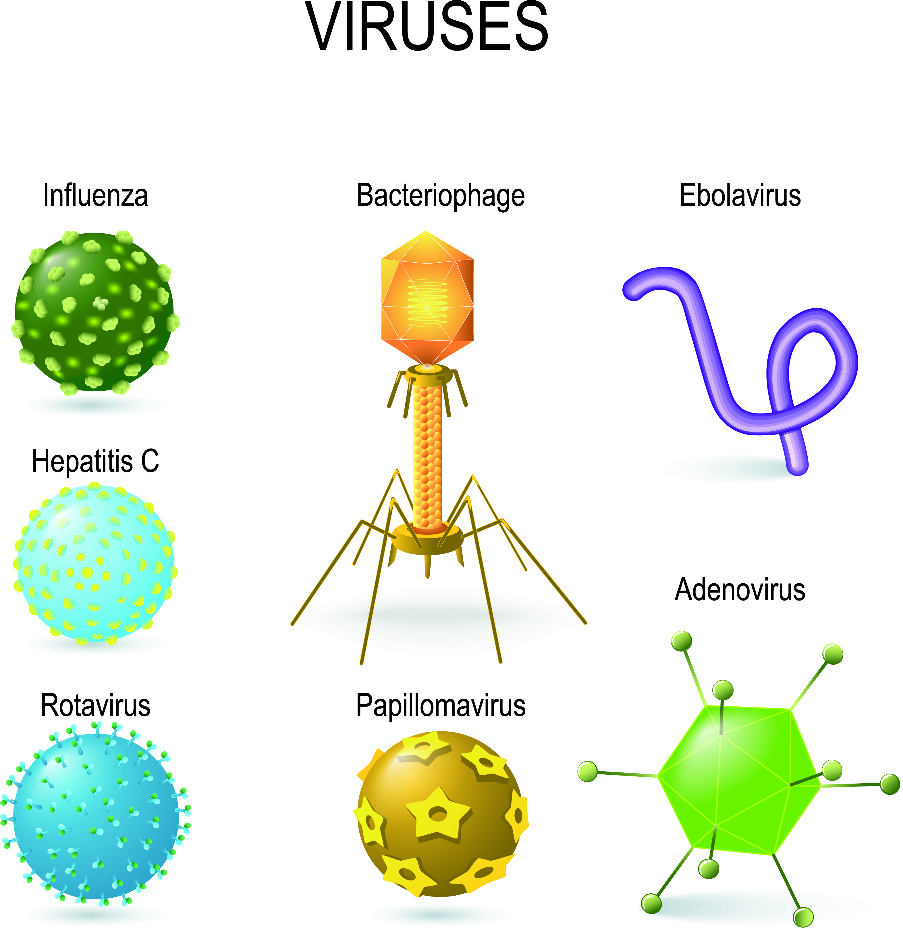

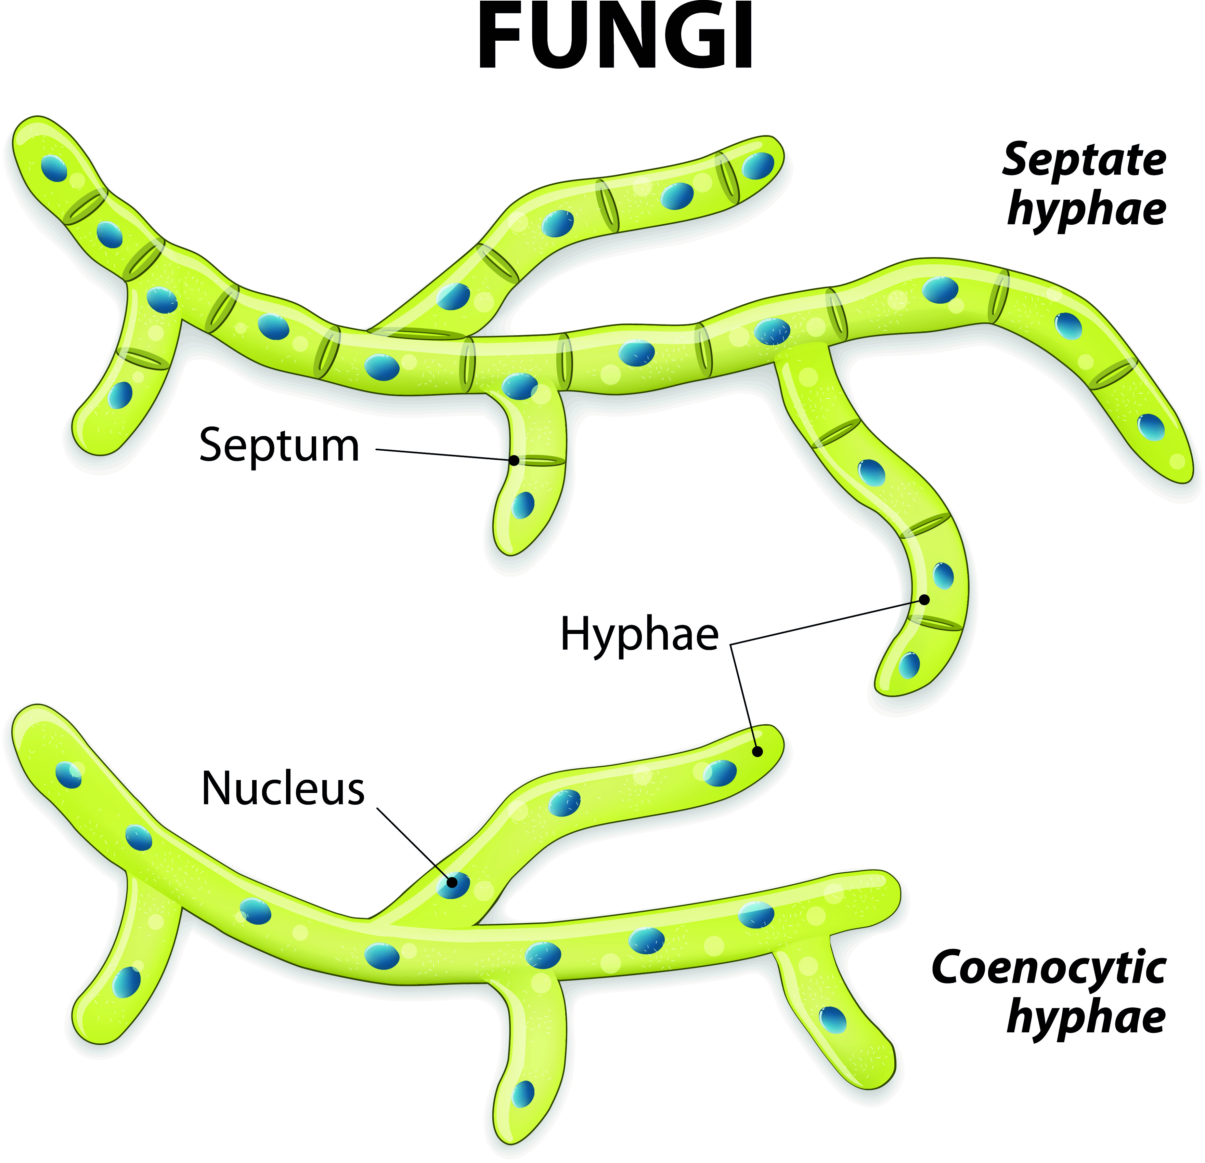

©iStock.com/ttsz

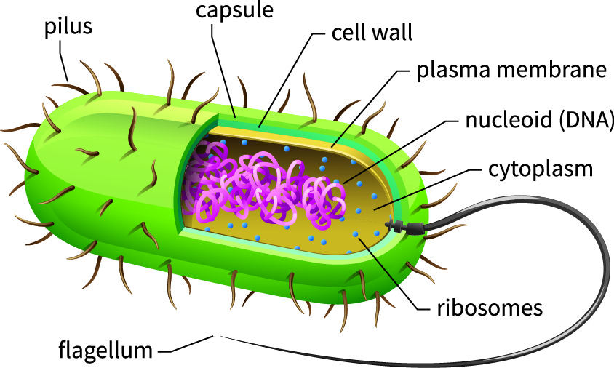

©Stock.com/jack0m

TASK 2: PO1 Identify the main groups of microorganisms in terms of their structure and function
Investigate and describe ways of identifying microorganisms:
- Gram staining
- Microscopy (light and electron microscopes)
- Colony characteristics

Present the evidence in a suitable way in your portfolio (P2).
Following research, tutor demonstration and learner practise of Gram staining, use the technique to identify a mixed culture of Gram negative and Gram positive bacteria. Ensure the evidence presented confirms you have used the Gram staining technique correctly (P3).
To achieve the (M2) provide an explanation of how these identification techniques are related to the structure of these microorganisms.
For the (D1), research and compare how various identification techniques are used in biotechnological industries and provide appropriate evidence in your portfolio.
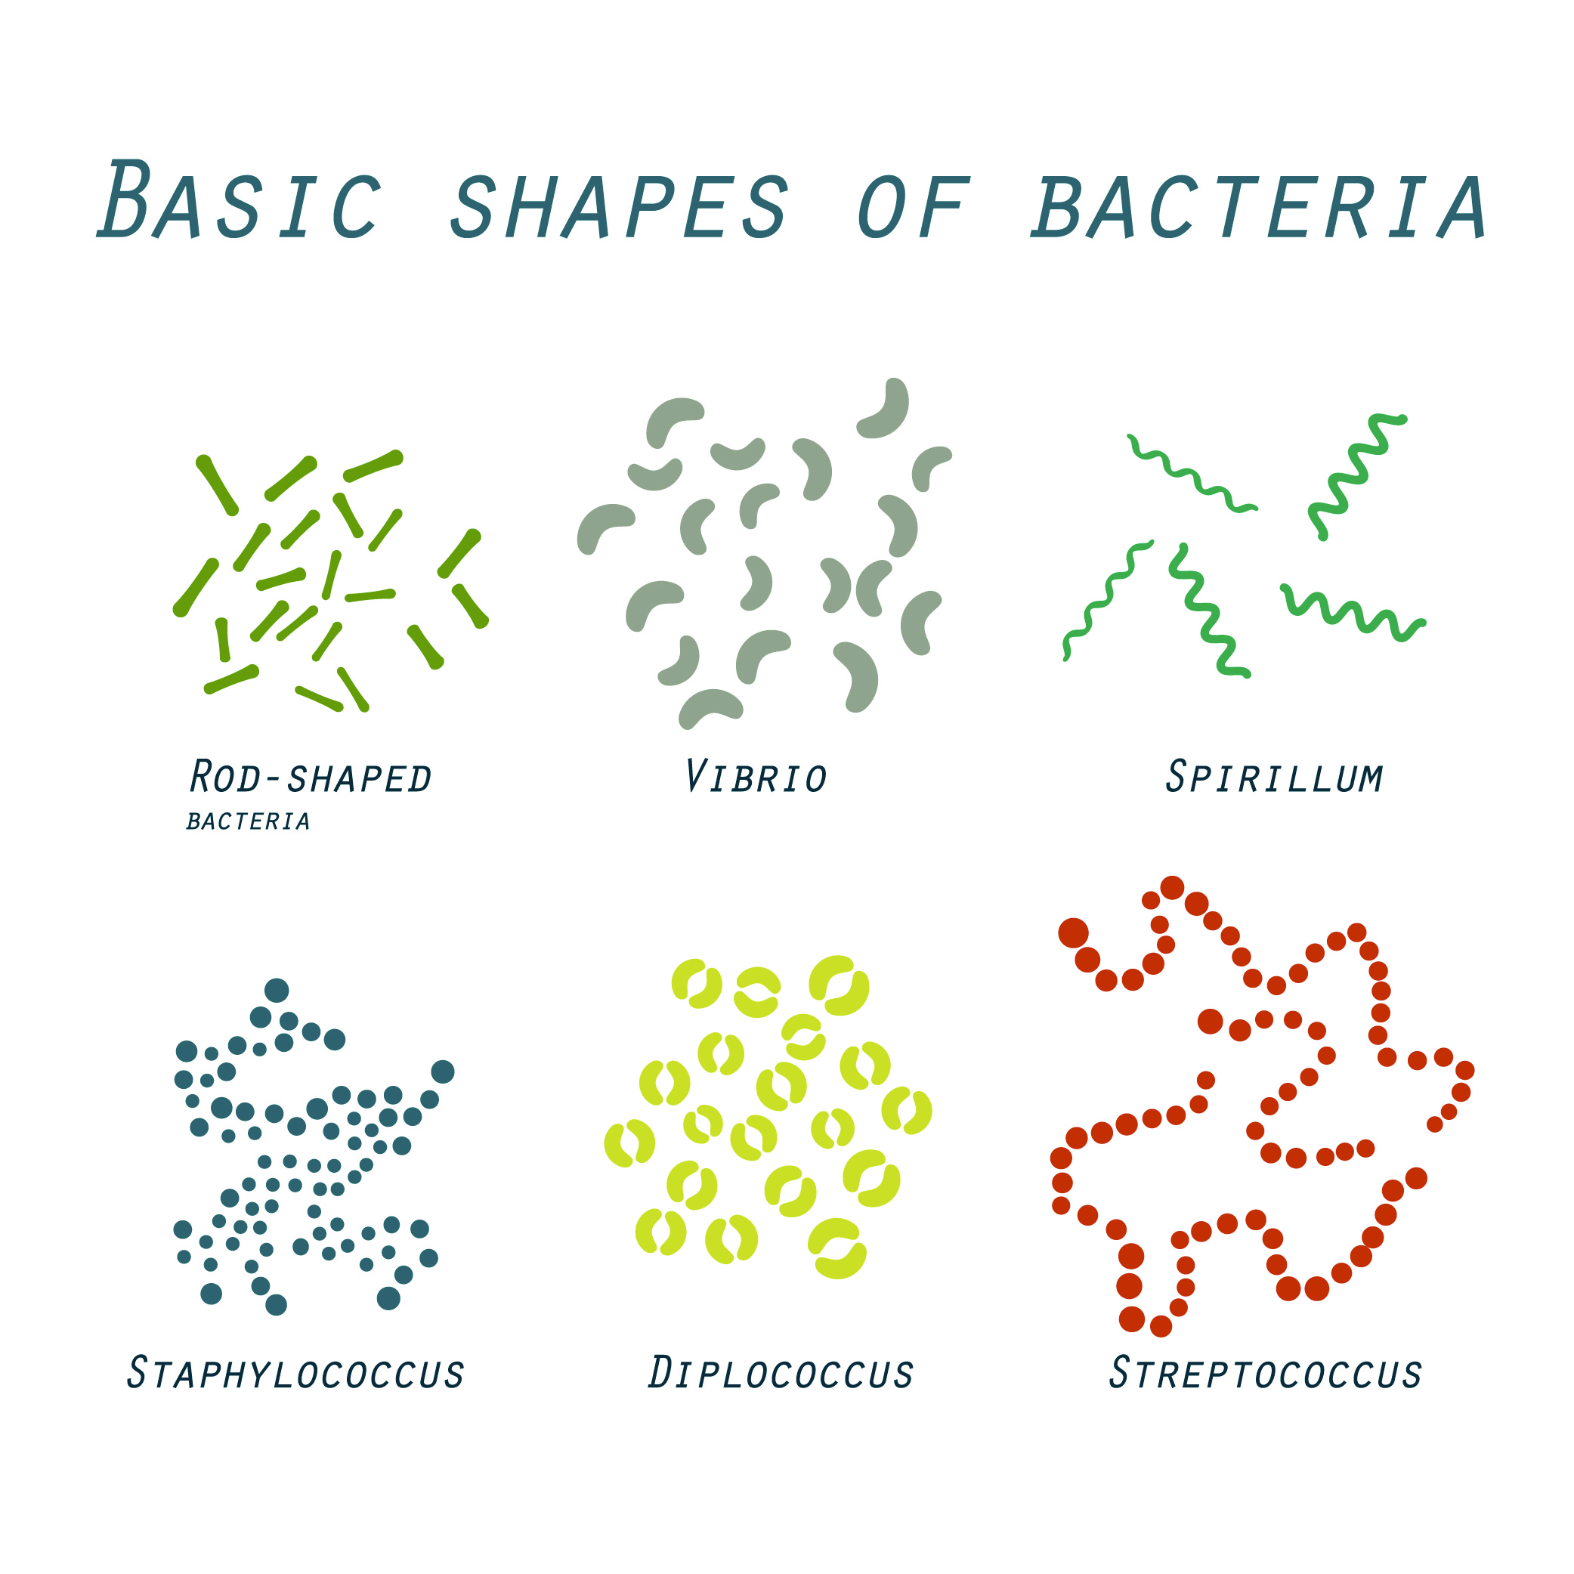

©iStock.com/robertprzybysz

TASKS 3a, 3b, 3c: PO2 Use aseptic techniques to safely cultivate microorganisms
Following research, tutor demonstration and learner practise of established cultivation techniques, select three of the following techniques to carry out ensuring at least two different types of microorganisms (chosen from bacteria, fungi and viruses) are used. Ensure risk assessments are undertaken (P4) and provide appropriate evidence of your practical work for your portfolio upon completion of the activities (P5):
- Streak plate
- Lawn plate
- Pour plate
- Mycelial disk
- Viral plaque

For the (M3), explain the control measures identified in the risk assessments which may be included in the risk assessments or identified as separate documentation. For completion of the merit criteria, the principles underlying the chosen cultivation techniques will require explanation in the portfolio evidence (M4).
The distinction (D2) will be achieved if the portfolio evidence reflects on the effectiveness of the techniques used and consideration given to how they could be improved.
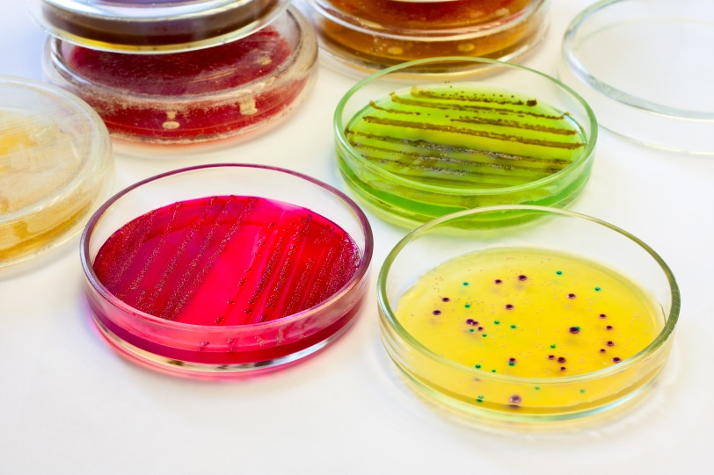

©iStock.com/cyano66

Useful Links

Difference between Bacteria, Virus and Fungi

Microbiology Online

HomeTeachersResources. Download Basic Practical Microbiology: A Manual

Science Buddies Interpreting Plates

Thermo Fisher Scientific : Aseptic Technique
MMU In the Loop Microbiology Services

Technical Notes

Download Basic Practical Microbiology: A Manual. A practical resource book covering health and safety techniques, aseptic techniques, microscopy, Gram staining, pour, streak and spread (lawn) plate methods
Microbiology Online

Manchester Metropolitan University MMU
in the Loop Microbiology Services

An Introduction to Practical Biology: a downloadable PDF which also covers the above basic techniques together with those for cultivating fungi can be found together with accompanying video presentations
Microbiology Society

Viruses: A practical resource for post-16 resource for biology teachers. Available for purchase or free to members.
Bacteriophage Plaque Assay for Phage Titer

