Sample assignment brief

Level 3 Certificate/Extended Certificate in Applied Science

Unit Name: 6b Medical Physics

Tutor/Assessor name
Assignment title | Assignment 2 Imaging and Radiotherapy Techniques
Date assignment issued |  | Submission date

Example of grading criteria
 | Pass | Merit | Distinction
Performance outcome

Assessment criteria to be evidence in the tasks provided | Criteria
Task 1 | P1 P2 M1 M2 D1 (6 hours)
Task 2 | P3 M3 D2 (4 hours)
Task 3 | P4 P5 M4 M5 D3 D4 (6 hours)
Task 4 | P6 M6 (4 hours)

Learner authentication
I confirm that the work and/or the evidence I have submitted for this assignment is my own. I have referenced any sources in my evidence (such as websites, text books). I understand that if I don’t do this, it will be considered as a deliberate deception and action will be taken.

Learner signature Date

Tutor/Assessor signature Date

Scenario:
Diagnostic imaging allows medical staff to look inside the body for clues about a medical condition. A variety of machines and techniques can create pictures of the structures and activities inside your body. The type of imaging your doctor uses depends on your symptoms and the part of your body being examined. Types of imaging include:
- X-rays - traditional and digital
- CAT scans
- PET scans
- Nuclear medicine scans
- MRI scans
- Ultrasound
- Thermography
Many imaging tests are painless and easy. Some require you to stay still for a long time inside a machine. This can be uncomfortable. Certain tests involve exposure to a small amount of radiation.
For some imaging tests, doctors insert a tiny camera attached to a long, thin tube into your body. This tool is called a scope. The doctor moves it through a body passageway or opening to see
inside a particular organ, such as your heart, lungs, or colon. These procedures often require an
aesthesia.
A Diagnostic Radiographer/Medical Imaging Technologist is a key member of the health care team. They are responsible for producing high quality medical images that assist medical
specialists and practitioners to describe, diagnose, monitor and treat a patients’ injury or illness. Much of the medical equipment used to gain the images is highly technical and involves state of the art computerisation.
A Diagnostic Radiographer/Medical Imaging Technologist needs to have the scientific and
technological background to understand and use the equipment within a modern Radiology
department as well as compassion and strong interpersonal skills. They need to be able to
demonstrate care and understanding and have a genuine interest in a patient's welfare. The
Diagnostic Radiographer/Medical Imaging Technologist will also need to be able to explain to the patient the need for the preparation and post examination care as well as the procedure to be
undertaken.
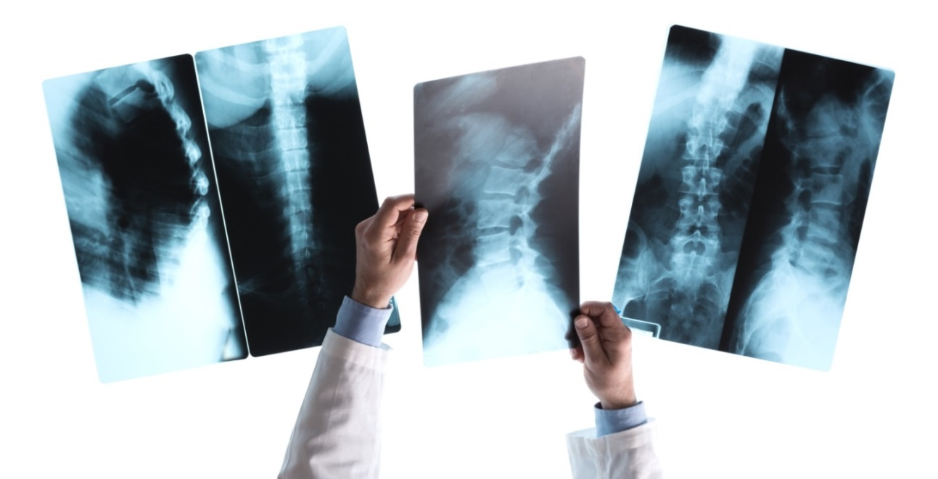

©iStock.com/cyano66

For your job as a diagnostic radiographer you are required to be familiar with all of the diagnostic techniques available in the NHS.

©iStock.com/maksymPoriechkin

The following tasks will assess your ability to understand the fundamentals of the main diagnostic imaging methods, the use of radioactive tracers and the use of radioisotopes in diagnosing diseases. The final task will assess your understanding of the precautions required for not only the patient but also for the members of staff using the isotopes.

PO1: Understand imaging methods

Task 1: (P1 P2 M1 M2 D1)

- X-rays - traditional and digital
- CAT scans
- PET scans
- MRI scans
- Ultrasound
- Thermography

The list above shows the main diagnostic imaging methods; to achieve P1 choose two of these methods and describe the basic way in which they work e.g. reference the use of filters and contrast media and exposure to X-rays. To achieve M1, link the underlying theory of each imaging method and use this to explain how the images are produced.
Carefully select ONE medical condition and for P2, identify a suitable and an unsuitable technique that can be used to investigate this condition. In order to obtain M2 explain why the suitable method would enable the medical staff to make a diagnosis and why the unsuitable method would not be appropriate for a diagnosis. Also consider the quality of the images and possible dangers to the patient.
To achieve D1 use calculations to support descriptions of the underlying theory of the two methods from P1 e.g. v = fl to calculate wave velocity, frequency and wavelength. The calculations should link to the dangers of using each technique.

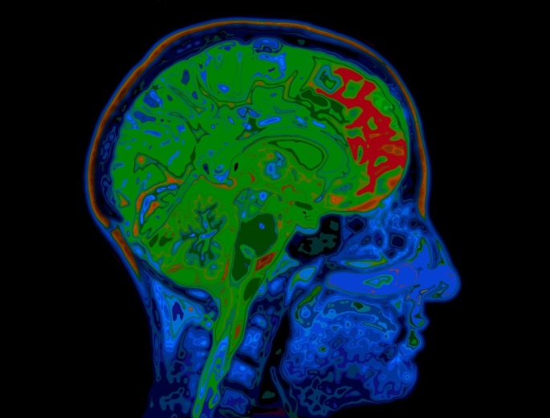
©iStock.com/highwaystarz-photography

All sources of information should be referenced.

PO2: Understand radiotherapy techniques and the use of radioactive tracers

Task 2 (P3 M3 D2)

Use diagrams to describe two radiotherapy techniques e.g. brachytherapy, intensity modulated radiation therapy (IMRT). For P3 use these diagrams and link these techniques to a specific disease or disorder.

To obtain M3 explain how each of the techniques from P3 is used to treat a specific disease or disorder e.g. treating leukemia with radionuclide therapy (RNT).
Radio Isotopes in Medicine

In order to attain D2 discuss the invasive nature of the techniques on patients e.g. look at the side effects of radiotherapy e.g. hair loss, fatigue etc.

All sources of information should be referenced.

Task 3 (P4 P5 M4 M5 D3 D4)

For P4 identify one radioisotope and describe its properties e.g. type of radiation emitted, toxicity and organ affinity. For M4 explain the importance of all of these properties and relate this to the relevant therapy. To attain D3 provide suitable calculations, these could include decay, half-life and emission reactions. Use these calculations as support for the explanations used for M4.

For P5 outline how radioisotopes can be used as tracers to identify abnormal bodily processes, testing of new drugs and conducting research into cures for disease. Give the properties of two radioisotopes for M5, describe what makes them suitable for use as tracers? Discuss types of radiation, toxicity, half-life etc.
Sourcing and evaluating quantitative data for D4 produce graphs and formulas relating to the two radioactive tracers and show calculations related to penetration power and effective half-life.
All sources of information should be referenced.
Measuring half life

Task 4 (P6 M6)
For P6 describe the dangers of radioactivity i.e. its effects on the body. What precautions are taken to protect not only the patient but also the medical staff?
To achieve the M6 explain the scientific principles that underlie the precautions.
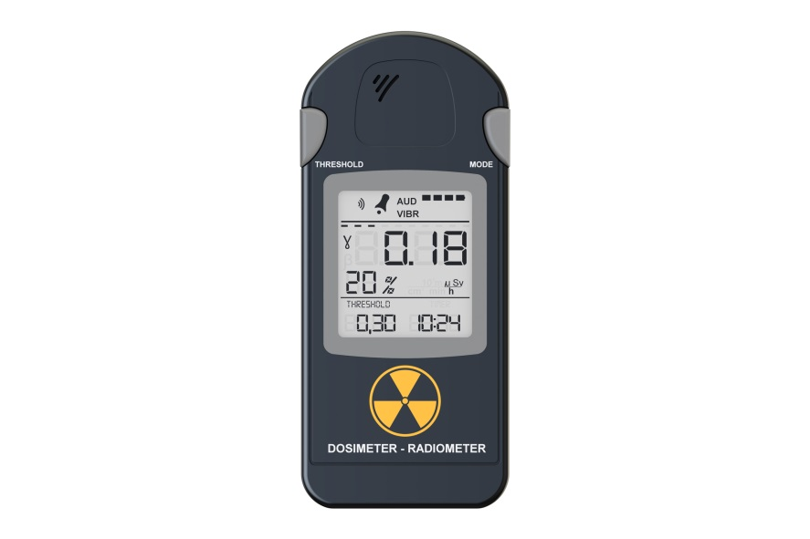

©iStock.com/AlexLMX

PO1 and PO2 may be covered using a single report as the evidence for all grading criteria.

Submission checklist (please insert the items the learner should hand in) | Confirm submission
Learner - please confirm that you have proofread your submission

