Applied General Assignment Brief
Unit 6c: Organic Chemistry (PO1 and PO2)

Qualification title | Level 3 certificate and extended certificate in applied science
Unit code | R/507/6504
Unit title | Organic Chemistry

Learner name
Tutor/Assessor name
Assignment Title | Assignment 1 Molecular structure, functional groups and isomerism
Date assignment issued |  | Submission Date

Performance Criteria
 | Pass | Merit | Distinction
Performance Outcome 1 | P1
 | P2 | M1 | D1
 | P3 | M2 | D2
 | P4 | M3 | D3
 | P5 | M4
Performance Outcome 2 | P6 | M5

Tasks | Performance criteria covered
Task 1 | P1 P3 M2 D2 (4 hours)
Task 2 | P2 M1 D1 (4 hours)
Task 3 | P4 P5 M3 M4 D3 (6 hours)
Task 4 | P6 M5 (2 hours)

Submission Checklist (please insert the items the learner should hand in) | Confirm submission
Task 1
Evidence for P1 is to produce posters, revision guides, PowerPoints or any other suitable concise reports, outlining each of the following areas: (i) bonding and structure, (ii) nomenclature, types of formulae and functional groups of compounds (using suitable examples for each)
For P3 produce evidence to identify one group of compounds with a commercial or industrial use and outline structures and uses for between 4-6 compounds in that group.
Show evidence for M2 by identifying two different compounds in the group for P3, provide detailed structures, skeletal formulas and identify functional groups using correct nomenclature and scientific terminology.
In order to obtain D2, pick a group of compounds (which may be different from that discussed in P3 and M2) that have a medical, commercial or industrial application and explain why the structure and/or functional groups make them suitable for their specific purpose.
[Note: for examples of suitable groups of compounds to study in P3, M2, D2, see Assessment Amplification p126 of the Specification]
Task 2
To obtain P2 produce a report to show different types of spectroscopic techniques including mass, infrared and NMR spectroscopy and typical examples of spectra produced by each technique.
For M1 describe how the spectra are obtained using the three techniques and outline the scientific principles involved in the production of the spectra from P2.
Produce evidence for D1 that explains how spectra can provide specific information about the structure of compounds. Peaks should be assigned (using researched data) and the effects of impurities explained. (One example of each of the three types of spectra is sufficient)
Task 3
For P4 produce an outline of the different types of structural and geometric isomerism and provide a suitable example for each type, this may be carried out as a poster, revision guide, Powerpoint, etc.
For M3 use the information from P4, on different types of isomerism, and give evidence of detailed examples using discussions of structures, shapes and molecular geometry. P4 and M3 may be carried out together in one report or Powerpoint presentation.
For P5 using examples found in biochemical systems (including lactic acid, alanine and limonene) give evidence to outline their optical isomerism. Reference should be made to terms such as asymmetric carbon atoms and chiral centres, and optical activity, and to the relationship between the three dimensional shapes of enantiomers.
For M4 give evidence to explain the importance of stereoisomerism in biochemical systems including reference to enzyme catalyzed reactions. Give one example of a compound and the specific uses, effects or actions.
In order to obtain D3 provide evidence for a detailed account of one compound which is biologically active. Explain the benefits and/or detrimental effects of its isomers in medical, commercial or industrial applications. The emphasis is on the isomers’ interaction with biochemical systems.
[Note: For more details for M4 and D3 see Assessment Amplification p126 of the Specification]
Task 4
To obtain P6 produce a concise report that gives examples of the different reactions of five functional groups. The following should be included: reagents, conditions, observations, equations for the reactions and explanations of the changes that occur to the functional groups.
For M5 provide evidence to explain how two of these reactions can be used as qualitative tests for functional groups.
Learner - please confirm that you have proofread your submission

Learner Authentication
I confirm that the work and/or the evidence I have submitted for this assignment is my own. I have referenced any sources in my evidence (such as websites, text books). I understand that if I don’t do this, it will be considered as a deliberate deception and action will be taken.
Learner Signature Date
Tutor declaration
I confirm the learner’s work was conducted independently and under the conditions laid out by the specification. I have authenticated the learner’s work and am satisfied that the work produced is solely that of the learner.
Tutor/Assessor Signature* Date
*Please record any assistance given to the learner beyond the group as a whole even if within the parameters of the specification

For marking purposes only

Marking grid

Performance Criteria (PC) Achieved |  |  |  |  |  |  |  |  | 1stsub* | Resub*
Pass | 1st sub*  ✓ / X** | Resub*  ✓ / X** | Merit*** | 1st sub*  ✓ / X** | Resub*  ✓ / X** | Distinction*** | 1st sub*  ✓ / X** | Resub*  ✓ / X** | Number of PCs achieved | Number  of PCs achieved
P1
P2 |  |  | M1 |  |  | D1
P3 |  |  | M2 |  |  | D2
P4 |  |  | M3 |  |  | D3
P5 |  |  | M4
P6 |  |  | M5
Total PCs achieved:

* Sub= submission and Re-sub=Re-submission (Re-submission column to be completed only if the learner has re-submitted the assignment.
** Achieved (✓ ) Not achieved (X). Please tick or cross for each performance criteria (PC)
*** Distinction and Merit criteria can be achieved only where the associated Merit and Pass criteria have been achieved first.

Tutor summative feedback for learner
(Note to tutors: this section should focus on what the learner has done well. Where a learner has not achieved a specific performance criterion or is likely to want to improve on a response to a performance criterion, then you may identify the issues related to the criterion, but should not provide explicit instructions on how the learner can improve their work to achieve the outstanding criteria.)*
Feedback

Tutor name(print) and date
Resubmission Feedback

Tutor name(print) and date

* All tutor notes should be deleted before the template is used.

Scenario:

Molecular structure holds a key to understanding Nature's intricate design mechanisms and blueprints. If we can understand these blueprints and basic materials, perhaps we can begin to reproduce these beautiful products more cost effectively and with less detrimental environmental consequences.

Molecular structure of Caffeine links
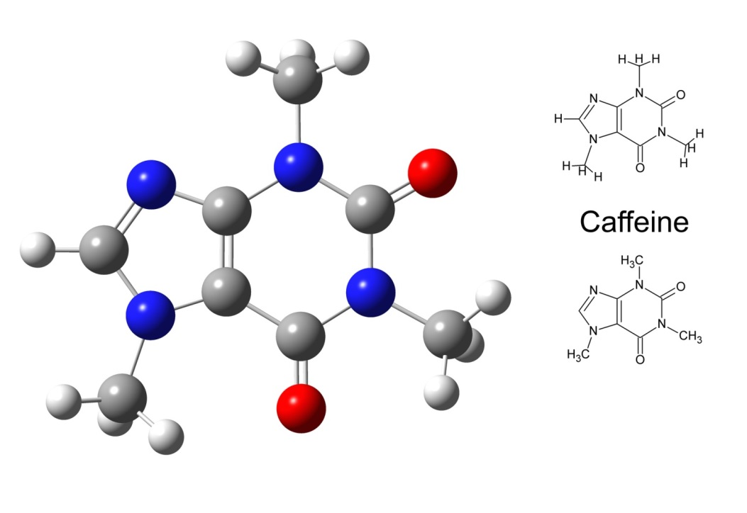
©iStock.com/chromatos

There are many chemicals used in medicine (drugs, anaesthetics, pain killers, antiseptics etc.) and hundreds of industries (food additives, fungicides, dyes, washing powder, flavours, fragrances, liquid crystals, biofuels and many more).

In order to "see" a molecule, we must use light having a wavelength smaller than the molecule itself (roughly 1 to 15 angstrom units). Such radiation is found in the X-ray region of the spectrum, and the field of X-ray crystallography yields remarkably detailed pictures of molecular structures amenable to examination. The chief limiting factor here is the need for high quality crystals of the compound being studied.

The spectroscopic techniques described below do not provide a three-dimensional picture of a molecule, but instead yield information about certain characteristic features. A brief summary of this information follows:

- Mass Spectrometry: Sample molecules are ionised by high energy electrons. The mass to charge ratio of these ions is measured very accurately by electrostatic acceleration and magnetic field perturbation, providing a precise molecular weight. Ion fragmentation patterns may be related to the structure of the molecular ion.
- Ultraviolet-Visible Spectroscopy: Absorption of this relatively high-energy light causes electronic excitation. The easily accessible part of this region (wavelengths of 200 to 800 nm) shows absorption only if conjugated pi-electron systems are present.
- Infrared Spectroscopy: Absorption of this lower energy radiation causes vibrational and rotational excitation of groups of atoms within the molecule. Because of their characteristic absorptions identification of functional groups is easily accomplished.
- Nuclear Magnetic Resonance Spectroscopy: Absorption in the low-energy radio-frequency part of the spectrum causes excitation of nuclear spin states. NMR spectrometers are tuned to certain nuclei (e.g. ¹H, ¹³C, ¹⁹F & ³¹P). For a given type of nucleus, high-resolution spectroscopy distinguishes and counts atoms in different locations in the molecule.
Activities

PO1: Identify molecular structure, functional groups and isomerism

As a trainee chemist in industry it is important to understand the underlying structure of different chemicals in order to know how these chemicals will react under different circumstances and what they can be eventually used for.

Task 1 (P1 P3 M2 D2)

For P1 produce posters, revision guides, PowerPoint presentations, or any other suitable concise reports, for a variety of organic compounds and functional groups (more than one in each)
outlining each of the following areas:

- bonding,
- structure,
- nomenclature,
- types of formulas

From the introduction there are many industries and commercial companies that use chemical compounds; pick an industry that interests you and investigate what chemical compounds they use. For P3 identify one group that the company uses and outline between 4-6 compounds including their structure and uses.

M2 for two different kinds of compounds in the group provide structures, skeletal formulas and identify functional groups using correct nomenclature and scientific terminology.

Industries will manufacture a chemical compound for a specific purpose and they will need to know if the compound is suitable for the proposed purpose. Much of the compounds’ suitability will lie with its structure. In order to obtain D2, pick a group of compounds that have a medical, commercial or industrial application and explain why the structure and/or functional groups present make them suitable for their specific purpose. For instance: Why are dyes coloured? How do the ingredients in flavourings and perfumes “work”? How does the structure of a liquid crystal cause its useful properties? How do anti-bacterials work?

Uses and Applications of various Compounds

All sources of information should be referenced

Part of your job is to identify different contaminants in a variety of products that need to be pure. These contaminants can be identified using different spectroscopic techniques. It is important to understand the different spectroscopic techniques and identify the contaminants in the spectra produced.

Task 2 (P2 M1 D1)

To obtain P2 produce a poster or other concise report to show different types of spectroscopic techniques including mass, infrared and NMR spectroscopy and an example for each technique of the spectra produced.

For M1 describe how the spectra are obtained from the three techniques and outline the scientific principles involved in the production of these spectra.

In order to obtain D1 explain how spectra can provide specific information about the structure of compounds.

All sources of information should be referenced

Chemical isomers are molecules that have the same molecular formula (the same number and types of atoms) but have different structural formulas (different arrangements of those atoms). This is important in chemical and biological systems as one isomer may have a different function to another isomer therefore it is important to know which is which.

The task below allows you to understand different types of isomers, their actions, uses and importance to biochemical systems.

Task 3 (P4 P5 M3 M4 D3)

For P4 outline the different types of structural and geometric isomerism and provide a suitable example for each type, this may be carried out as a poster or other concise report format..

For M3 use the information from P4 on different types of isomerism, and give detailed examples using discussions of shape and molecular geometry. P4 and M3 may be carried out together as a PowerPoint presentation.

For P5 using examples found in biochemical systems (including, for example, lactic acid, alanine and limonene) outline their optical isomerism.

For M4 explain the importance of stereoisomerism in biochemical systems. Give one example of a compound and the specific uses, effects or actions.

In order to obtain D3 provide a detailed account of one compound which is biologically active. This could include an enantiopure drug e.g. Naproxen, Thalidomide, cis- and trans- fatty acids, flavours and fragrances. Explain the benefits and/or detrimental effects of its isomers in medical or commercial or industrial applications. The emphasis is on the isomers’ interaction with biochemical systems.

For P5, M4 and D3 use a suitable medium to produce the evidence

All sources of information should be referenced

PO2 Understand reactions of functional groups

A functional group is a portion of a molecule that is a recognisable/classified group of bound atoms. In organic chemistry it is very common to see molecules made up mainly of a carbon backbone with functional groups attached to the chain. The functional group gives the molecule its properties; they are centres of chemical reactivity. The functional groups within a molecule need to be identified when naming the molecule.

Functional Group Name Example
Amine CH₃NH₂ (methyl amine)

Task 4 (P6 M5)
To obtain P6 produce a report that gives examples of the different reactions of five functional groups. The following should be included (a simple statement is all that is intended):

- reagents
- conditions
- observations
- equations for the reaction
- explanations of the changes that occur to the functional groups.

For M5 explain how two of the reactions can be used as qualitative tests for functional groups.

[Note: Assessment Amplification p127 of the Specification gives suitable examples for M5]

