ELC Science

Component 1 – Biology: How the body works, Outcome 4

Component | Skill Area A | Skill Area B | Skill Area C | Skill Area D | Skill Area E | Total mark
1 | 1/2/3 | 1/2/3 | 1/2/3 | 1/2/3 | 1/2/3 | /15
Investigative activity: Which food stores the most energy? Crisps or biscuits?

Information:

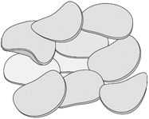
I know that…
If food can be set alight, energy is released.
This energy can be used to heat up some water.
Some foods have more energy stored than others.
We need the right amount of energy to keep us healthy.

What am I trying to find out?

Skill Area A: Planning
Entry Level 1

Tick () which items of equipment you will need from the list below:

kettle |  | beeswax polish |  | laboratory stand and clamp
beaker |  | 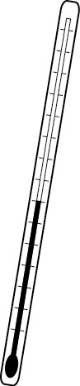  thermometer |  | butter
balance 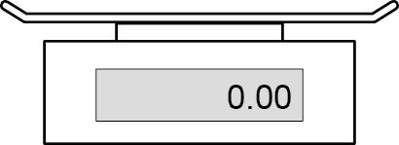 |  | marker pen |  | 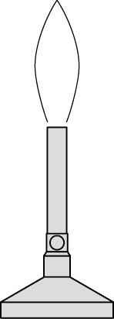  Bunsen burner
candle wax |  | heating gauze |  | 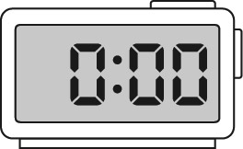  stop watch
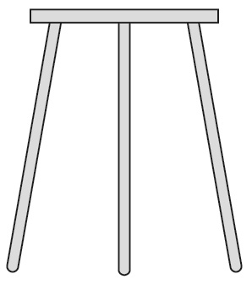  tripod |  | margarine |  | boiling tube
wooden splint |  | 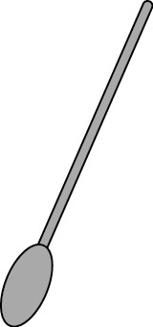  spatula |  | 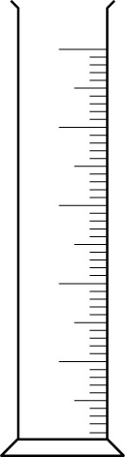  measuring cylinder

Any other equipment needed?

How will I set up the apparatus? Draw diagram here.

Skill Area A: Planning
Entry Level 2
What I’m going to do (this can be bullet points or a flow chart)
……………………………………………………………………………………………………………………………………………………………………………………………………………………………………
…………………………………………………………………………………………………………………
…………………………………………………………………………………………………………………
…………………………………………………………………………………………………………………
…………………………………………………………………………………………………………………
…………………………………………………………………………………………………………………
…………………………………………………………………………………………………………………
…………………………………………………………………………………………………………………
…………………………………………………………………………………………………………………
…………………………………………………………………………………………………………………
…………………………………………………………………………………………………………………

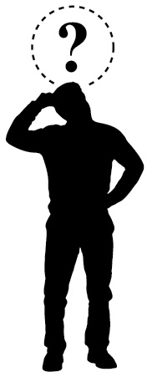
To make it a fair test,
I am going to keep these things the same:
……………………………………………………………………………

I am only going to change
…………………………………………………………………………………………………………………

I am going to measure …………………………………………… using …………………………

Skill Area A: Planning
Entry Level 3

What I think might happen
I think the food that stores the most energy will be ……………………………………………………………………............................................................
because…………………………………………………………………………………………………………………………………………………………………………………………………………………………………………………………………………………………………………………………………………………………………………………………………………………………………………………………………
………………………………………………………………………………………………………
……………………………………………………………………………………………………………………………………………………………………………………………………………………………………………………………………………………………………………………………………………………....

Skill Area B: Doing
Entry level 1 and 2
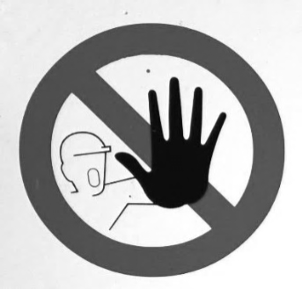
Skill Area B
I have used the equipment in an organised and safe way to get my results
I worked safely
Level 3

I can trust my results because …………………………………………………………....
……………………………………………………………………………………………………………….…
………………………………………………………………………………………………………………….………………………………………………………………………………………………………………….………………………………………………………………………………………………………………….
………………………………………………………………………………………………………………….

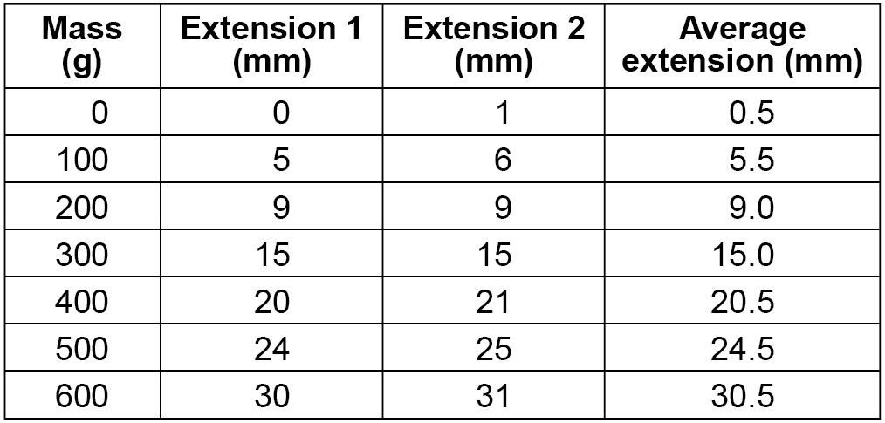
Skill Area C: Recording data (my observations)

Entry levels 1, 2 and 3

My results:
Think carefully about your variables and units (what you are measuring?)

Skill Area D: Processing and presenting data
Showing patterns in my results
Entry levels 1, 2 and 3
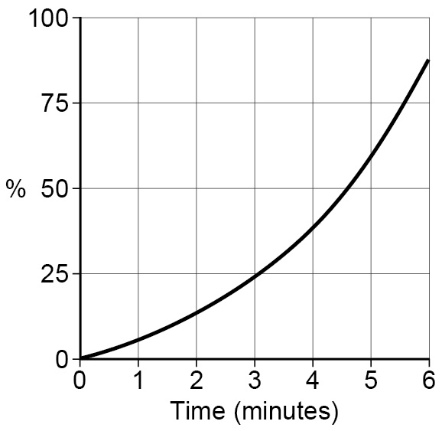
I am going to use a: bar chart 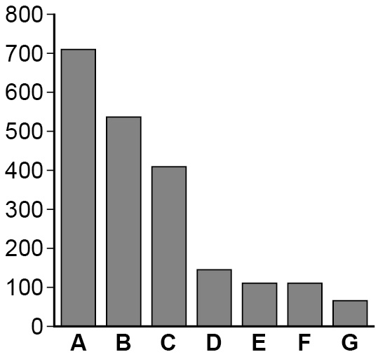

line graph to show the results I collected
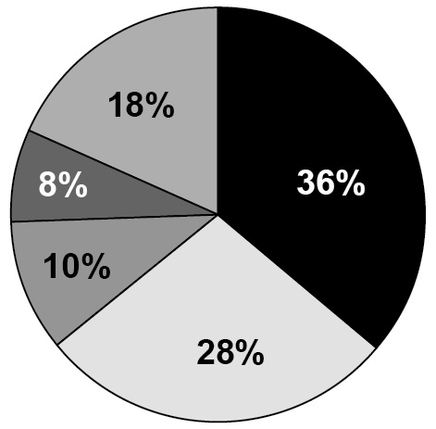

pie chart

other

Show or attach your processed data here:

Skill Area E: Interpreting and Evaluating
Levels 1, 2 and 3

Conclusion: My evidence tells me that the food that transferred the most energy as heat was…………………..…………………………………………………………………………………………
…………………………………………………………………………………………………………………..
…………………………………………………………………………………………………………….….…
………………………………………………………………………………………………………………..…
My evidence shows this because (describe any patterns or trends in your results) ……………………………………………………………………………………………………..……………
………………………………………………………………………………………………………..…………
………………………………………………………………………………………………………………..…
…………………………………………………………………………………………………………………..
………………………………………………………………………………………………..…………………
………………………………………………………………………………………………………..…………
…………………………………………………………………………………………………………..………
………………………………………………………………………………………………………..…………
…………………………………………………………………………………………………………..………

Skill Area E: Evaluating
Level 3 only

How does my evidence match my prediction?
…………………………………………………………………………………………………………………..
……………………………………………………………………………………………………….………….
…………………………………………………………………………………………………………………..
…………………………………………………………………………………………………………………..
Could I make my evidence even better? Explain how you could improve what you did.
…………………………………………………………………………………………………………………..
…………………………………………………………………………………………………………………..
…………………………………………………………………………………………………………………..
…………………………………………………………………………………………………………………..
…………………………………………………………………………………………………………………..

