# ELC Science

## 3.2 Component 2: Biology

## Environment, evolution and inheritance – Outcome 7

|  |  |  |  |  |  |  |
| --- | --- | --- | --- | --- | --- | --- |
| **Component** | **Skill Area A** | **Skill Area B** | **Skill Area C** | **Skill Area D** | **Skill Area E** | **Total mark** |
| **2** | **1/2/3** | **1/2/3** | **1/2/3** | **1/2/3** | **1/2/3** | **/15** |

**Investigative activity: Is there more pollution near a road?**

**Information:**



Pollution in the air from smoke and gases can come from car exhausts.

Plants need water and light to grow.

If they don’t get enough of either, it will affect how they grow.

Particles of dust and soot in the air can collect on different surfaces such as leaves.

|  |
| --- |
| **What am I trying to find out?** |

**Skill Area A: Planning**

**Entry Level 1**

**Tick () which items of equipment you will need from the list below:**

|  |  |  |  |  |  |
| --- | --- | --- | --- | --- | --- |
| kettle |  | beeswax polish |  | laboratory stand and clamp  P:\1 - Find graphics by category - DO NOT USE (Under Construction)\Equipment\SI-6 Clamp stand.jpg |  |
| P:\1 - Find graphics by category - DO NOT USE (Under Construction)\Equipment\SI-2 Beaker.jpg  beaker |  | P:\1 - Find graphics by category - DO NOT USE (Under Construction)\Equipment\SI-4 Thermometer.jpg  thermometer |  | butter |  |
| balance P:\1 - Find graphics by category - DO NOT USE (Under Construction)\Equipment\SI-2 Balance.jpg |  | marker pen |  | P:\1 - Find graphics by category - DO NOT USE (Under Construction)\Equipment\SI-3 Bunsen with small blue flame.jpg  Bunsen burner |  |
| candle wax |  | heating gauze |  | P:\Locate images by category\4 - Standard equipment\SI-3 Stop clock.jpg  stop watch |  |
| tripod |  | margarine |  | P:\1 - Find graphics by category - DO NOT USE (Under Construction)\Equipment\SI-1 Boiling tube.jpg  boiling tube |  |
| wooden splint |  | P:\Locate images by category\4 - Standard equipment\SI-5 Spatula.jpg  spatula |  | P:\1 - Find graphics by category - DO NOT USE (Under Construction)\Equipment\SI-4 Measuring cylinder.jpg  measuring cylinder |  |

|  |
| --- |
| **How will I set up the apparatus?** **Draw diagram here.** |

**Skill Area A: Planning**

**Entry Level 2**

|  |
| --- |
| **What I’m going to do** (this can be bullet points or a flow chart).  ……………………………………………………………………………………………………………………………………………………………………………………………………………………………………  …………………………………………………………………………………………………………………  …………………………………………………………………………………………………………………  …………………………………………………………………………………………………………………  …………………………………………………………………………………………………………………  …………………………………………………………………………………………………………………  …………………………………………………………………………………………………………………  …………………………………………………………………………………………………………………  …………………………………………………………………………………………………………………  …………………………………………………………………………………………………………………  ………………………………………………………………………………………………………………… |

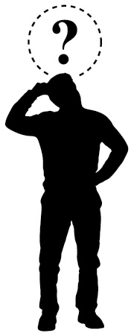To make it a **fair test**,  
  
I am going to keep these things **the same:**

……………………………………………………………………………

I am only going to **change**

…………………………………………………………………………………………………………………

I am going to **measure**  …………………………………………… using …………………………

**Skill Area A: Planning**

**Entry Level 3**

|  |
| --- |
| **What I think might happen**  ……………………………………………………………………............................................................  …………………………………………………………………………………………………………………………………………………………………………………………………………………………………………………………………………………………………………………………………………………………………………………………………………………………………………………………………………  because………………………………………………………………………………………………………  …………………………………………………………………………………………………………………………………………………………………………………………………………………………………………………………………………………………………………………………………………………….... |

**Skill Area B: Doing**

**Entry level 1 and 2**

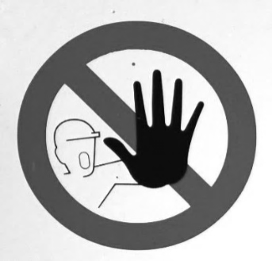**Skill Area B**

I have used the equipment in an organised and safe way to get my results

I worked safely

**Level 3**

|  |
| --- |
| I can trust my results because …………………………………………………………....  ……………………………………………………………………………………………………………….…  ………………………………………………………………………………………………………………….………………………………………………………………………………………………………………….………………………………………………………………………………………………………………….  …………………………………………………………………………………………………………………. |

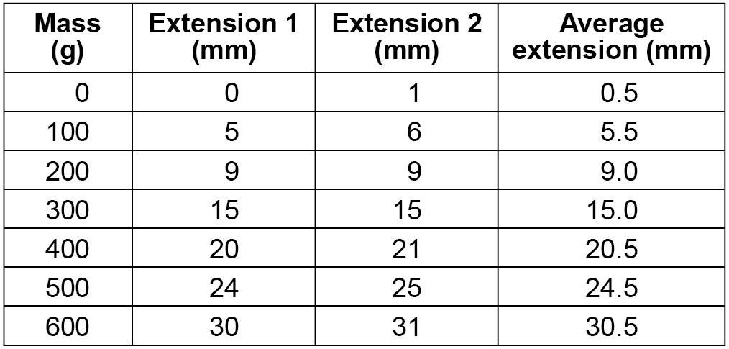

**Skill Area C: Recording data (my observations)**

**Entry levels 1, 2 and 3**

|  |
| --- |
| **My results:**  Think carefully about your **variables** and **units** (What you are measuring?) |

**Skill Area D: Processing and presenting data**

Showing patterns in my results

**Entry levels 1, 2 and 3**

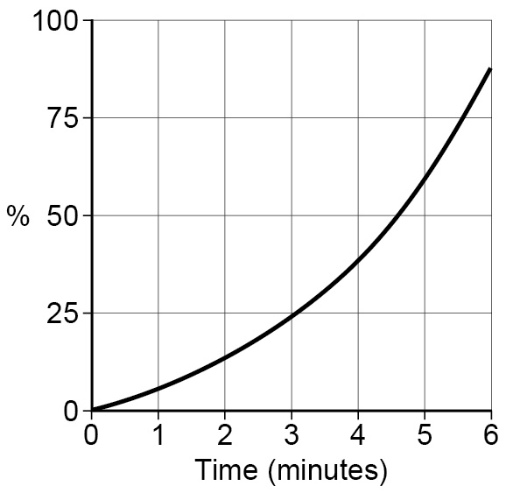I am going to use a: **bar chart** 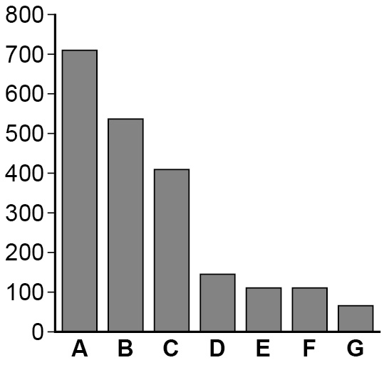

**line graph to show the results I collected**

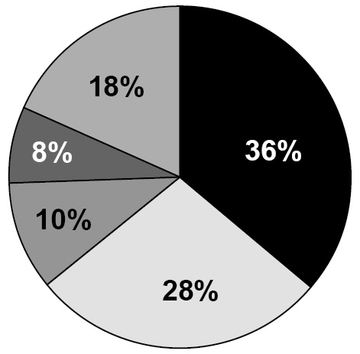

**pie chart**

**other**

Show or attach your processed data here:

**Skill Area E: Interpreting and Evaluating**

**Levels 1, 2 and 3**

|  |
| --- |
| **Conclusion: My evidence tells me that** …………………..………………………………………………………………………………………………  …………………………………………………………………………………………………………………..  …………………………………………………………………………………………………………….….…  ………………………………………………………………………………………………………………..…  **My evidence shows this because** (describe any patterns or trends in your results) ……………………………………………………………………………………………………..……………  ………………………………………………………………………………………………………..…………  ………………………………………………………………………………………………………………..…  …………………………………………………………………………………………………………………..  ………………………………………………………………………………………………..…………………  ………………………………………………………………………………………………………..…………  …………………………………………………………………………………………………………..………  ………………………………………………………………………………………………………..…………  …………………………………………………………………………………………………………..……… |

**Skill Area E: Evaluating**

**Level 3 only**

|  |
| --- |
| **How does my evidence match my prediction?**  …………………………………………………………………………………………………………………..  ……………………………………………………………………………………………………….………….  …………………………………………………………………………………………………………………..  …………………………………………………………………………………………………………………..  **Could I make my evidence even better?** Explain how you could improve what you did.  …………………………………………………………………………………………………………………..  …………………………………………………………………………………………………………………..  …………………………………………………………………………………………………………………..  …………………………………………………………………………………………………………………..  ………………………………………………………………………………………………………………….. |