ELC Science

3.4.5 Component 4: Chemistry in our world, Outcome 10
Teacher Devised Assignment: Student writing frame

Component | Skill Area A | Skill Area B | Skill Area C | Skill Area D | Skill Area E | Total mark
4 | 1/2/3 | 1/2/3 | 1/2/3 | 1/2/3 | 1/2/3 | /15

Investigative activity: Which water sample would be the safest to use as drinking water?

Information

Water that is safe to drink has small amounts of dissolved substances and low levels of microbes.

What am I trying to find out?

Skill Area A: Planning
Entry Level 1

Tick () which items of equipment you will need from the list below:

kettle |  | beeswax polish |  | laboratory stand and clamp
beaker |  | 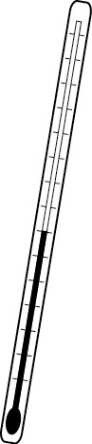  thermometer |  | butter
balance 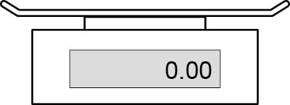 |  | marker pen |  | 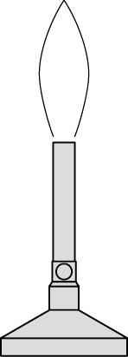  Bunsen burner
candle wax |  | heating gauze |  | 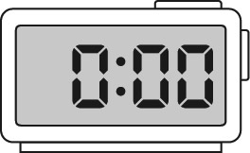  stop watch
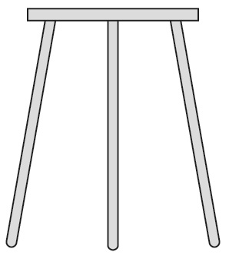  tripod |  | margarine |  | boiling tube
wooden splint |  | 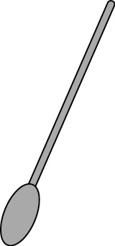  spatula |  | 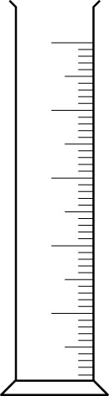  measuring cylinder

Any other equipment needed?

How will I set up the apparatus?: Draw a simple diagram

Planning Skill Area A: Entry Level 2

What I’m going to do (This can be bullet points or a flow chart)
……………………………………………………………………………………………………………………………………………………………………………………………………………………………………
…………………………………………………………………………………………………………………
…………………………………………………………………………………………………………………
…………………………………………………………………………………………………………………
…………………………………………………………………………………………………………………
…………………………………………………………………………………………………………………
…………………………………………………………………………………………………………………
…………………………………………………………………………………………………………………
…………………………………………………………………………………………………………………
…………………………………………………………………………………………………………………
…………………………………………………………………………………………………………………

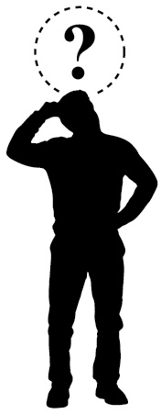
To make it a fair test,
I am going to keep these things the same:
……………………………………………………………………………

I am going to only change
…………………………………………………………………………………………………………………

I am going to measure …………………………………………… using …………………………

Planning Skill Area A: Entry Level 3

What I think might happen
I think the water safe to drink will be……. ……………………………………………….. because
……………………………………………………………………............................................................
…………………………………………………………………………………………………………………………………………………………………………………………………………………………………………………………………………………………………………………………………………………………………………………………………………………………………………………………………………
………………………………………………………………………………………………………
……………………………………………………………………………………………………………………………………………………………………………………………………………………………………………………………………………………………………………………………………………………....

Doing

Skill Area B: Entry level 1 and 2
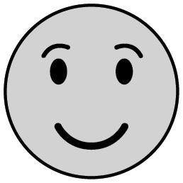
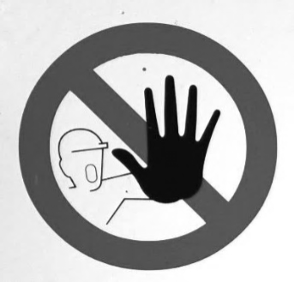
Skill Area B – Level 3
I have used the equipment in an organised and safe way to get my results
I worked safely

I can trust my results because …………………………………………………………....
……………………………………………………………………………………………………………….…
………………………………………………………………………………………………………………….………………………………………………………………………………………………………………….………………………………………………………………………………………………………………….
………………………………………………………………………………………………………………….

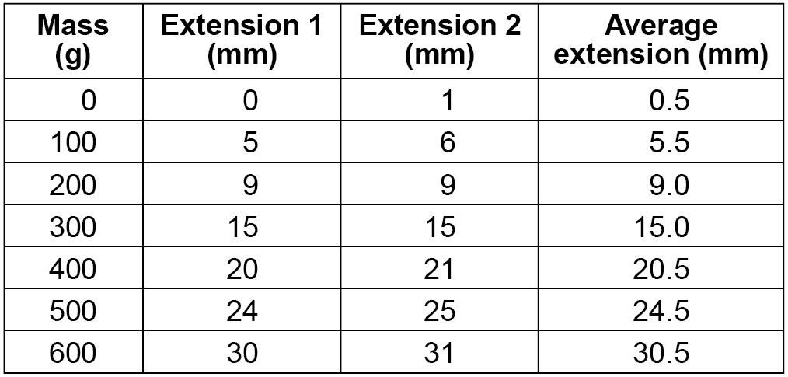
Skill Area C: Recording data (my observations)

Entry levels 1, 2 and 3

My results:
Think carefully about your variables and units (What you are measuring?)

Skill Area D: Processing and presenting data
Showing patterns in my results
Entry levels 1, 2 and 3
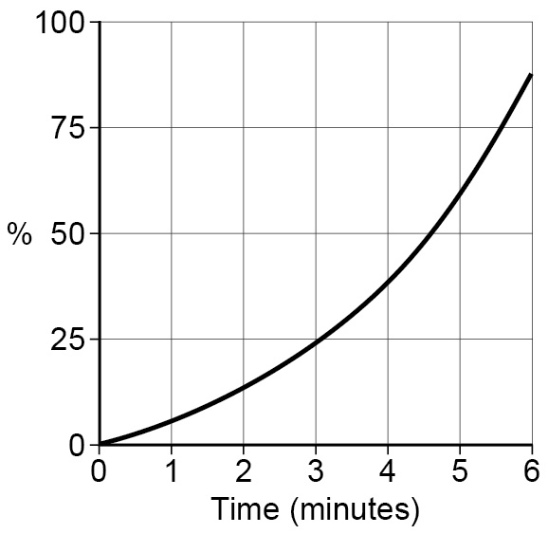
I am going to use a: bar chart 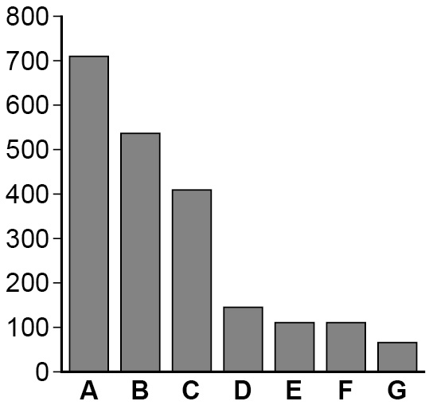

line graph to show the results I collected
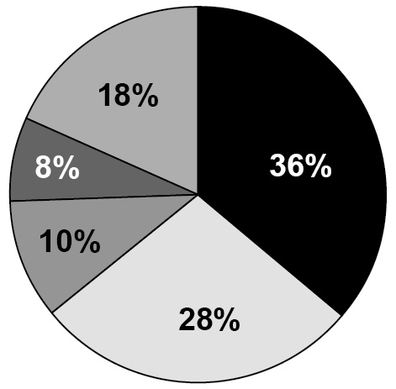

pie chart

other

Show or attach your processed data here:

Skill Area E: Interpreting and Evaluating
Levels 1, 2 and 3

Conclusion: My evidence tells me that the water that is safest to drink is: …………………..………………………………………………………………………..
…………………………………………………………………………………………………………………..
…………………………………………………………………………………………………………….….…
………………………………………………………………………………………………………………..…
My evidence shows this because (Describe any patterns or trends in your results) ……………………………………………………………………………………………………..…
………………………………………………………………………………………………………..…………
………………………………………………………………………………………………………………..…
…………………………………………………………………………………………………………………..
………………………………………………………………………………………………..…………………
………………………………………………………………………………………………………..…………
…………………………………………………………………………………………………………..………
………………………………………………………………………………………………………..…………
…………………………………………………………………………………………………………..………

Skill Area E – Level 3 only Evaluating

How does my evidence match my prediction?
…………………………………………………………………………………………………………………..
……………………………………………………………………………………………………….………….
…………………………………………………………………………………………………………………..
…………………………………………………………………………………………………………………..
Could I make my evidence even better? Explain how you could improve what you did.
…………………………………………………………………………………………………………………..
…………………………………………………………………………………………………………………..
…………………………………………………………………………………………………………………..
…………………………………………………………………………………………………………………..
…………………………………………………………………………………………………………………..

