

India Matters

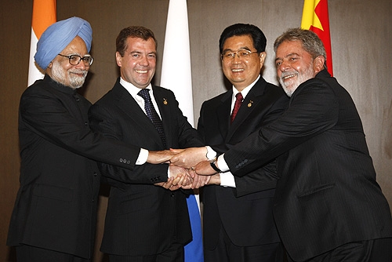

Cambridge IGCSE India Studies Newsletter 13
June 2011
IN THIS ISSUE
Page

Updated Timeline 3

Syllabus for 2012 examinations 3

Fact Box 1: India’s labour force & taxation 3

Mr & Mrs Iyer: film question for 2012 (Paper 3) 3

‘Power games: Two nations in a spin over cricket.’ 3

‘India's Economy is booming, but not for everybody.’ 5

‘India cheers rising tiger numbers amid habitat concerns’. 5

Fact Box 2: India’s major trading partners 6

‘India world's largest arms importer.’ 6

New Resources List 7

Professional Development Training for teachers 7

Appendix: Resource Bank: Education 8

India Matters sets out to support subject teachers in Pilot schools, aiming to keep Centres informed and seeking to encourage the spread of ideas and the exchange of good practice. Please keep in touch with feedback.

India Matters is published every other month and emailed to each Pilot Centre. All India Studies teachers in your Centre should have a copy so please circulate it to everyone involved. There is no restriction on photocopying.

Martin D W Jones
Product Manager
University of Cambridge International Examinations
1 Hills Road, Cambridge, CB1 2EU, UK
fax: +44 (0)1223 553558
phone: +44 (0)1223 553554
international@cie.org.uk

[The cover photograph shows the leaders of the BRIC nations (L to R: India, Russia, China and Brazil) at their summit in 2010. Think about how and why this picture might be used when discussing each of the “key issues for study and examination” in Paper 1 Themes 2 and 4.]
Updated Timeline
The timeline on the Discussion Forum has been updated. Adapted from the India Timeline on the BBC News website, this is a useful summary of some key events covered by the syllabus. Copies might usefully be given to every India Studies student. A copy might also be posted in every India Studies classroom.

Syllabus for 2012 examinations
The 2012 syllabus has been on CIE’s website and the IGCSE India Studies eDiscussion Forum since mid-2010. No topic has been added or removed. No topic has been altered. What should be taught remains exactly the same as for the 2011 examinations.

In response to questions from teachers, however, we took the opportunity to make two clarifications:
- the teaching time that should be devoted to each Theme and Case Study (p.6), and
- the description of the Paper 1 examination (p.5) - candidates answer any three questions.

Fact Box 1: India’s labour force & taxation

435 million work in the informal economy.
35 million work in the formal economy.

Only 3% of India’s population (35 million people) pay income tax.

Mr & Mrs Iyer: film question for 2012 (Paper 3)
If any of your students wish to pick the India in Film question for their Portfolio, they might like to know that large parts of Mr & Mrs Iyer (2002; directed by Aparna Sen), the nominated film, may be accessed without charge in 9 minute chunks on You Tube. They will need to study the whole film and it is readily available on DVD, but this extra way to watch Mr & Mrs Iyer might be useful at times.

A recent newspaper article on India-Pakistan cricket offered some useful political context too:


‘Power games: Two nations in a spin over cricket.’
India and Pakistan compete today for the first time since the Mumbai terror attacks. Andrew Buncombe sees the political and cultural frenzy begin.
30 March 2011

… When it emerged India were to meet Pakistan in the semi-finals, India's Prime Minister, Manmohan Singh, decided he would attend the game and invited his Pakistani counter-part to join him. Two days later, Pakistan announced that Yousaf Raza Gilani would take up the invitation. Since then, speculation has spread at a feverish pace about just what this so-called cricket diplomacy may or may not achieve.

… The long history of antagonism between the two nuclear-armed neighbours, who have gone to war four times since Partition in 1947, has little need of further rehearsal. Neither does the dark pit into which the already fraught relationship fell after the 2008 attacks, carried out by Pakistani militants.

There are fewer places in the subcontinent where the painful dysfunction of the relationship is more clearly viewed than here. Though the Indian state of Punjab rubs up against the Pakistani province of Punjab, very few people have any contact with their neighbours on the other side, even though in many cases they speak the same language – Punjabi – and share similar customs. "As members of the public, we don't have any differences. We are the same. It's just the difference between politicians," suggested another fan, Vikash Bansal, who works in IT.

Such a view was shared by the small number of Pakistani fans who have managed to get hold of tickets. "It's good if the relationship between the two countries can thaw," said Raza Sanuallah, a young man from Lahore …

Mr Singh and Mr Gilani have agreed to have dinner after today's match and officials say there will be discussion on various issues. But aides have been keen to play down any breakthrough on those hard issues still keeping the countries at loggerheads, namely India's demand that Pakistan do more to bring the perpetrators of the Mumbai attacks to justice and Pakistan's insistence that Kashmir is a "disputed" territory.

… Cricket diplomacy has been attempted before between the two countries and with mixed results. In 1987, Pakistan's military ruler Gen Zia al-Haq attended a test match between India and Pakistan in Jaipur, describing it as part of his "cricket for peace initiative". It is claimed, however, that during the game the general leaned forward to his host, the late Rajiv Gandhi, and told him that Pakistan had acquired the nuclear bomb.

Cricket was more of a balm in 1999 when, for the first time in more than a decade, the two countries played each other less than six months after exploding their nuclear devices. Likewise in 2004 when India toured Pakistan, the then-military ruler General Pervez Musharraf used the opportunity to tell Indian prime minister Atal Vajpayee that Pakistan would no longer allow its territory to be used for terrorist purposes. The following year, Mr Musharraf was invited to a match in Delhi by Mr Vajpayee's successor, Manmohan Singh.

It is that example, perhaps, that those who place hope in the broader benefits of today's game seek to remember. "The importance of cricket diplomacy is in the curative effect it tends to have on people-to-people relationships even if it does nothing for government-to-government equations," said M K Akbar, a veteran commentator on India-Pakistan relations and author of a new study of India's neighbour, Tinderbox: The Past and Future of Pakistan. "And cricket has dried up. This match is an accident and all the more exciting for it. For a day at least cricket will drain some of the poison in a toxic environment."

[For the full article, see http://www.independent.co.uk/news/world/asia/power-games-two-nations-in-a-spin-over-cricket-2256744.html ]

‘India's Economy is booming, but not for everybody.’
A recent programme from 'Planet Money' on National Public Radio, USA has some interesting material and useful ideas for the Cambridge IGCSE India Studies syllabus. Parts would make an excellent base for class discussion or for homework tasks to investigate.

The programme’s publicity states, “In India, there are a handful of billionaires, and 400 million people without electricity. On today's Planet Money, we ask the question: With India's economy growing at 8% per year, why are so many people there still so poor? We hear from economists and from Umrao Singh, a 75-year-old cobbler who lives on the street in Delhi.”

Broadcast on 4/6/2010, this programme is available as an audio podcast (lasting 24 minutes):
http://www.npr.org/blogs/money/2010/06/04/127480338/the-friday-podcast-india-s-economy-is-booming-but-not-for-everybody

A recent news release and news film report about tigers offered useful, up-to-date context on environmental sustainability linked to economic development:


‘India cheers rising tiger numbers amid habitat concerns.’
Matthias Williams
New Delhi, 28 March 2011

The number of Indian tigers living in the wild rose to 1706 at the latest count, giving a boost to conservation efforts for the endangered species in the country with the world's largest population of the big cats. But the government raised concern over a sharp decline in the habitat where tigers were found, which could shrink further if the government goes ahead with new development projects.

"We have a mixed bag," Environment Minister Jairam Ramesh said at the release of the tiger census in New Delhi. "We have reason to feel satisfied with what we have done. But the threats are imminent."

The New Delhi government has for decades been fighting a losing battle to conserve tiger numbers against poaching, which feeds a lucrative cross-border trade in body parts, and the loss of natural habitat. Tiger numbers have plummeted 97% from 100,000 at the turn of the last century.

… The total area where tigers were found has fallen to 72,800 sq km from 93,600 sq km over three years. The rise in tiger numbers was good news for conservation efforts, though the surge could be partly down to better data …

Tiger conservation is a hot-button issue in India, which pits the need to preserve wildlife against the development needs of a country with blistering economic growth rates, but hundreds of millions living below the poverty line.

Power shortages in particular are seen as a major constraint to faster economic growth, putting pressure on the environment ministry from vested interests to permit the development of coal mines and hydroelectric dams.

"We can deal with the poachers," said Ramesh, who has held up hundreds of projects over environmental concerns in defiance of concerns from other ministries. "We can deal with the mafias, the real estate mafias and the mining mafias, but what is difficult to deal with is the development dynamic, because there is the need for higher and faster economic growth."

[For the full text, see http://in.reuters.com/article/2011/03/28/idINIndia-55928720110328 ]
plus
related to this article, see also ‘Learning to live with India's endangered tigers’, a 3 minute film of December 2010 about the work of the Tiger Research & Conservation Trust in the Tadoba Tiger Reserve, Maharashtra, from BBC News: http://www.bbc.co.uk/news/world-south-asia-12057732

Fact Box 2: India’s major trading partners

Exports Imports
to UAE 13% from China 11%
to USA 11% from UAE 7%
to China 11% from USA 6%
to Singapore 4% from Saudi Arabia 4%
from Australia 4%
from UK 4%

Figures are for 2009 and show the major destinations for India’s exports and the major sources of India’s imports (China includes Hong Kong).

A recent news report about arms imports helpfully set these in the wider context of India’s business development:

‘India world's largest arms importer.’
The latest Arms Transfers Database of the Stockholm International Peace Research Institute (published March 2011) shows that India is now the world's largest importer of weapons.

The report says ‘India received 9% of the volume of international arms transfers during 2006–10, with Russian deliveries accounting for 82% of Indian arms imports. Indian imports of major conventional weapons are driven by a range of factors. The most often cited relate to rivalries with Pakistan and China as well as internal security challenges’, states Siemon Wezeman of the SIPRI Arms Transfers Programme. ‘As an importer, India is demanding offsets and transfers of technology to boost its own arms industry and, in order to secure orders, major suppliers are agreeing to such demands’.

[For the full text, see http://www.sipri.org/media/pressreleases/armstransfers ]
New Resources List
The 7th edition is about to be posted to the eForum. In these updated listings, new items have been added for almost every Theme and Case Study. Teachers might look out especially for

- the URL on p.3 to ‘Strategic Asia’, an information portal from The National Bureau of Asian Research, Seattle, USA which gives free access to a database for Asia-Pacific countries (including India) covering 1990-2007. Areas covered are: Economy, Finance, Trade and Investment, Population, Energy and Environment, Communications and Transportation, Armed Forces, Politics, International Relations.
- a new section (p.5) headed ‘What key issue face India in the coming years?’
- clearer headings for each section and sub-section.

and new URLs to web-based materials for

- Paper 1 Theme 1 on the question of new states within the Union;
- Paper 1 Theme 2 on entrepreneurs;
- Paper 1 Theme 2 on links between economic development and (a) international trade,
(b) transport infrastructure and (c) sustainable development;
- Paper 1 Theme 4 on relations with Bangladesh, China, Russia and Sri Lanka;
- Paper 2 Case Study 2 on education.

Professional Development Training for teachers
An online training course for India Studies teachers will be held during academic year 2011-2012. Details will be circulated to schools well in advance.

Please keep in touch – with each other as well as CIE.

Appendix: Resource Bank: Education

In this issue, we offer a series of resources that might be of value when considering with your class aspects of Paper 2 Case Study 2, especially Key Issues 2. Parts are also relevant to Paper 1 Theme 3 Key Issues 1 and 4.

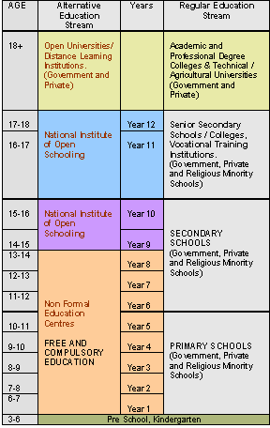
Overview of the structure of India’s Education System

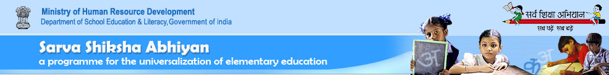
‘Girls Education in India: Achievements since Independence.’
Ministry of Human Resource Development Press Release, 24 January 2008

The leaders of our freedom movement realized the importance of girls’ education and had put it as a prime agenda for national development. However, when India attained independence some 60 years ago, it was a formidable challenge that the new government had to face … Social and cultural barriers to education of women and lack of access to organized schooling, had to be addressed immediately.

Access To Schooling Improved
Education administrators gave high priority on reducing the infrastructure/access deficiency. Focused attention on this need has resulted in establishing a network of 7,67,520 schools at the primary level and 2,74,731 schools at the upper primary level by 2004-05 from just 2,09,671 primary and 13,596 upper primary schools in 1950-51. A large majority (87%) of these are rural schools. Today 98% of India’s rural population has access to primary schools within a kilometer of the habitation.

Greater access to schooling is, however, not enough. Special measures are called for to help girls join the schools. These include setting up of girls toilets and providing separate girls’ schools at upper primary level to counter community resistance to girls’ studying in co-educational schools. Some schools are residential ones – the recent addition to residential schools being the Kasturba Gandhi Balika Vidyalayas that target the most disadvantaged girls at the upper primary stage.

The Government continues to be the major provider of elementary education with 90% primary and 72% upper primary schools managed either by Government or by local bodies. Annual maintenance grants and school improvement grants are being provided to each school at the elementary level.

Upswing In Girls’ Enrolment
Growth in access to schooling has been matched by a steady increase in enrolment, with the most dramatic upswing since 1990s in girls participation levels at the primary level [and] at the upper primary level …

The proportion of girls in the total enrolment has also been growing … The overall improvement in girls’ enrolment with respect to total population of girls clearly shows that there is a near universal enrolment at primary level. The gap and challenge exists now at upper primary stage, but there too the gap is narrowing steadily.

Enrolment of Scheduled Caste and Scheduled Tribe girls poses a greater challenge to India’s education administrators. Survey data, however, revealed that the participation of these disadvantaged girls in basic education, has grown steadily over the years …

Constitutional And Policy Framework
The Constitution of India in Article 15(1) on right to equality provides the basic policy framework that enshrines the vision of girls’ education and the spirit in which their education is to be provided.

… The 86th Constitutional Amendment Act 2002 has made elementary education a Fundamental Right for children in the age group of 6-14 years by providing that “the State shall provide free and compulsory education to all children of the age of six to fourteen years in such manner as the State may, by law, determine”. This has been a path breaking legislation in India, where such a major commitment to the cause of elementary education has bound governments, community based organizations and civil society into a common resolve to achieve universal elementary education …

[For the full text, see http://ssa.nic.in/news/girls-education-in-india-achievements-since-independence-press-release-wednesday-january-23-2008/ ]

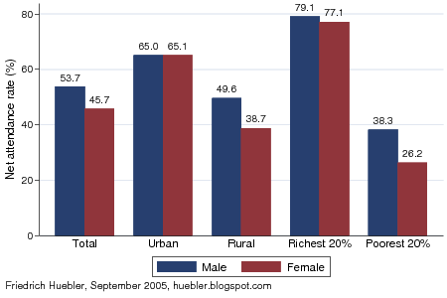
Secondary school attendance, 2004-05

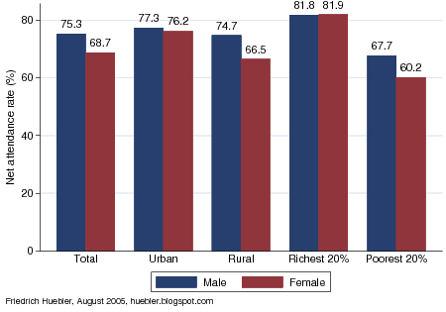
Primary school attendance, 2004-05

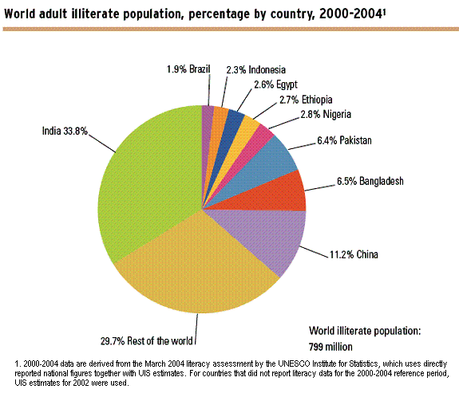


‘Girls Education Camp, Barabanki, Uttar Pradesh.’
UNICEF Switzerland

Founded in 2001 by UNICEF, ‘Girls Education Camp’ is a successful program that enables girls from the lowest social class to catch up on primary education within one year.

Fifty-four percent of the worldwide 100 million illiterate children are girls. The reason for why girls do not attend school is either because their parents lack the resources to give their daughters an education or because their parents do not consider an education for girls as important.
When funds are limited, parents are more likely to send their sons to school than their daughters, even though experience shows that educated girls get married later and have fewer children. They are also much more likely to know their rights and be able to safeguard themselves from discrimination, violence and risks such as HIV/AIDS. As parents, they are also much more likely to send their children to school.

Girls – a Priority for UNCIEF
Experience shows that if a developing country succeeds in lowering the illiteracy rate among women, the infant mortality rate and birth rate decline and per capita income increases. This is why girls’ education is one of UNICEF’s five priorities. One of the eight Millennium Development Goals is to achieve primary education for all girls and boys by 2015.

Schools for Girls: A Showcase Project
The ‘Girls Education Camp’ in Barabanki, a district in Uttar Pradesh, is one of many educational UNICEF initiatives to achieve better school enrolment for girls. During an intensive course, girls without a formal education between 10 and 14 years old can make up the missed curriculum within one year. Subsequently, they can join the public school’s sixth grade. Besides the traditional subjects, girls are instructed in practical subjects such as hygiene, healthful nutrition, precautionary measures in health and family planning.

450 000 Students in 9600 Schools
The ‘Girls Education Camp’ was initiated within a broader educational campaign in Barabanki. One third of the 180 million residents of Uttar Pradesh live below the poverty line. Half of all children are malnourished. Only 27 percent of girls and 50 percent of boys complete fifth grade. By financially supporting schools and alternative educational centers in remote areas, UNICEF Switzerland enables these children to attend school. Emphasis is placed on girls from the lowest social classes.

So far, 450 000 students attend class in 9600 schools. UNICEF supports the launching of new schools, training of teachers, supplying schools with teaching and learning materials, as well as mobilizing and educating the public. Raising the public’s awareness is an essential factor when convincing parents of the importance of education for their daughters.

The government assumes responsibility of every school three years after it has been initiated. Aware that it cannot increase educational achievements, especially among girls, by itself, the government partners with foreign organizations and local nonprofits to achieve this goal …

[For the full article, see http://www.unicef-suisse.ch/it/contributi_donazioni/padrinati_progetto/india/schools_for_girls_in_india/ ]

Circuses told to stop employing children.’
19 April 2011

India's highest court ordered circuses to stop employing children yesterday and instructed the government to rescue and rehabilitate those currently working for the shows. India's Child Labour Act bans employment of children younger than 14, but circuses were exempt until six months ago when the government amended the law. But circus owners have largely ignored the law, and now the Supreme Court is mandating that it be enforced.

India is home to the greatest number of child labourers despite efforts to address the problem through compulsory education and anti-poverty programmes. Activists say the number working in circuses could be in the thousands. They often perform the most dangerous stunts, including on the trapeze or high wires and frequently without safety nets.

The court ruled on a petition from the Indian group the Save the Childhood Movement, filed in 2006 after the group studied children in circuses ...

[For the full article, see http://www.independent.co.uk/news/world/asia/circuses-told-to-stop-employing-children-2269645.html ]

‘For a girl in rural India, education is a difficult pursuit.’
23 March 2007

Anuradha Rathore knows of no women doctors in her native village or its surrounding area. Among her 100 classmates at the Sampurnanand Medical College in Jodhpur, she is one of 30 females.

The 20-year-old medical student grew up in Kansera, a remote village in Rajasthan. At that time, children were able to go to school only up to the fifth year of primary school, Rathore said. "Nothing beyond that." In the last couple of years, educational opportunities have improved there: A coed school now goes up to grade 8.

While India's economy booms, educational opportunities remain out of grasp for large numbers of rural poor, especially girls ... Although government programs are in place to address education and poverty, they have failed to deliver on a large scale because of a lack of resources and accountability, a 2005 report by the Childhood Poverty Research and Policy Centre found.

In nine of India's 35 states and territories, illiteracy rates among women are 50% or higher, according to figures from the 2001 India census. By contrast, no state or territory has an illiteracy rate of 50% or higher among males.

… In recent weeks, the government has sought to alleviate economic disparities between rural and urban areas with a budget plan that would increase rural, health and education spending by $16.3 billion, nearly half - $7.3 billion - of which would go to education.

In Rathore's village, girls are not expected to get an education, and many end their schooling at grade 6 or 7, she said, referring to 12 to 14-year-olds. "It is basically the old school of thought," Rathore said, "that a girl is to be married and studying is a waste of money and resources, and there is no need for girls to study beyond a certain level." Illiteracy is the outcome. In Rajasthan, 44% of all females are literate compared to 76% of males, the census found.

'Hardly any coed schools around'
That Rathore's village offered education only at the primary level is not unique, said Thrity Cawasji, a UNICEF assistant communication officer. Many villages only have primary schools, and children may have to travel far to go to secondary schools, she explained - a situation that can render education difficult at best when walking is the only means of getting somewhere.

Other factors that contribute to attrition in secondary school, particularly among girls, are school fees, child marriages, a shortage of teachers, inadequate toilet facilities - a basic need, as girls reach menstrual age - and the lack of support from parents and the community, Cawasji said.

School fees, which can range from 100-200 rupees (or US $2-$5) per month in rural areas, added onto the costs of books and possibly uniforms, can be costly for impoverished families with several children. "If the family can't educate its children, the girls would be pulled out before the boys," said Cawasji, adding that girls are considered more valuable at home.

Many parents want to keep boys and girls separate in schools beginning at the intermediate education level, says Shrimohan Arora, school manager at the Amar Chand Kanya Intermediate College for girls in Atrauli, Uttar Pradesh.

The alternative might be no school for girls, Arora acknowledged, adding that many parents want their daughters to attend Amar Chand Kanya. Even if the parents didn't care about girls mixing with boys, obstacles would remain for the teenage girl, Arora said. "For intermediate education, there are hardly any coed schools around," Arora said. "For boys, there are many schools."

Few role models
… Rathore never had role models. But she's been chosen as one of 15 "Girl Stars" in an India-wide campaign that's using 15 films, books and posters to celebrate girls' education and what females can do. In short, to create female "icons" of everyday women and girls … Rathore's desire is to work with the government and serve as a doctor at the village level. Not necessarily in her own village of Kansera, she said, but "any village."

[For the full article, see http://edition.cnn.com/2007/WORLD/asiapcf/03/15/girl.education/index.html ]

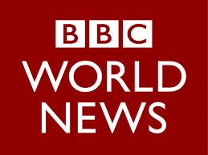
‘India: The next university superpower?’
2 March 2011

India has ambitious plans to increase graduate numbers in a way which would give it the size and status of an education superpower. The figures are staggering. India's government speaks of increasing the proportion of young people going to university from 12% at present to 30% by 2025 - approaching the levels of many Western countries.

It wants to expand its university system to meet the aspirations of a growing middle class, to widen access, and become a "knowledge powerhouse". It will mean increasing the country's student population from 12 million to over 30 million, and will put it on course to becoming one of the world's largest education systems. "We will very likely be number two if not number one in terms of numbers," says Pawan Agarwal, a former civil servant and author of Indian Higher Education: Envisioning the Future …

'Great leap forward'
K N Panikkar, vice chairman of the Kerala State Higher Education Council, describes India's higher education spending as undergoing a "great leap forward" …

But there is a steep hill to climb. India's National Knowledge Commission estimated the country needs 1,500 universities compared to around 370 now. Hundreds of new institutions are being set up, including large new public universities in each state. The number of prestigious Indian Institutes of Technology (IITs) and Management (IIMs) are being expanded from seven to 15.

India's private university sector is also growing rapidly, particularly in professional education in information technology, engineering, medicine and management where there is huge demand from the burgeoning middle classes.

But that will not be enough. To bridge the gap the government last year tabled legislation to invite foreign universities to set up branch campuses. The Foreign Providers Bill is currently making its way through parliament. Last year there were reports of up to 50 foreign universities being interested in setting up in India.

… Mr Panikkar says foreign and private institutions are not the answer. "If only 1% of the population can afford the fees, then it will be very serious for the country in terms of equity."

Fair access
Access is an important issue for the government which came to power because the benefits of India's rapid economic growth were seen to have bypassed the country's poor. While more than 95% of children now attend primary school, just 40% attend secondary school, according to the World Bank. That in itself will limit growth in university enrolment.

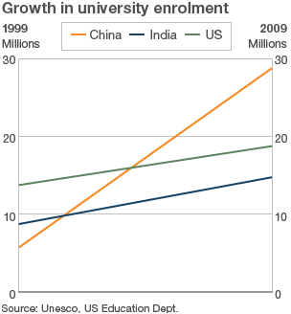

The World Bank has said India's economic success cannot be sustained without major investment in education, including higher education, with public spending on the sector still lagging behind countries like China and Brazil …

That means huge public spending on colleges outside the cities, says Mr Panikkar who has written extensively on social justice in higher education. He believes the enrolment targets are too ambitious given limited public resources and bottlenecks in staffing and infrastructure. "What is achievable is adding perhaps 10 million students to existing capacity in the next five to seven years," he says.

That would still be a major achievement, but some way from making India an education superpower.

[For the full article, see http://www.bbc.co.uk/news/business-12597815 ]

