Storage Devices
1. Draw four lines to match each storage medium to the most appropriate use in this list.
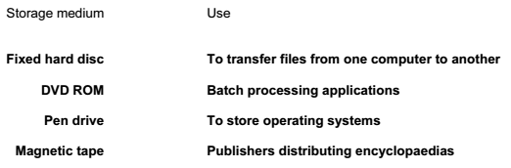

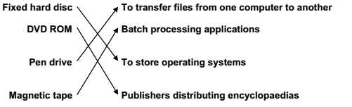
2. Optical discs and magnetic tapes are both used to store computer data.
Give two uses of optical discs and for each use give a reason why they are preferred to magnetic tapes.
Two matched pairs from:
- Companies selling their software/games
- Cheap method of production/quick to access data
- Making personal backups/transferring data (from one computer to another)
- Cheap to buy/quicker to retrieve data/expensive to buy tape drives
- Downloading/Copying media such as films/music
- Faster/Easier to access individual scenes/tracks/ better or higher quality
3. Use the most appropriate phrase from the list below to complete each sentence.
store data in real time applications
store high definition films
store backups of file servers
store music for sale
store photographs in a digital camera
(i) A CD ROM is used to………… ……………………..
(ii) A blu-ray disc is used to …………. ………………
(iii) A magnetic tape is used to ………………. ……
(iv) A flash memory card is used to………………..

(i) A CD ROM is used to store music for sale
(ii) A blu-ray disc is used to store high definition films
(iii) A magnetic tape is used to store backups of file servers
(iv) A flash memory card is used to store photographs in a digital camera

4. Describe four features of ROM.
Fourfrom:
- Read only memory
- Can be read from but not written to/can’t be changed/edited
- Used to store BIOS/start up programs for computer
- Used to store software that must not change e.g. games
- Non-volatile/permanent (memory)

5. Ring two items which are used to store data.

6. Tick whether the following statements apply to RAM or apply to ROM.
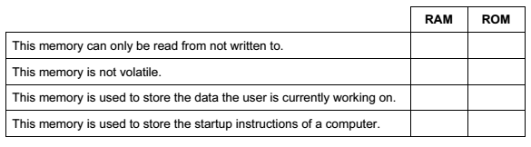
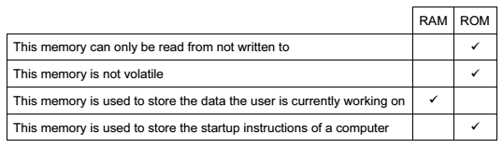
7. Ring two items which are used for storing data.

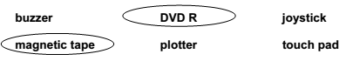

8. Use the most appropriate phrase from the list below to complete the sentences.
retouch photographs.
print out photographs.
input candidate examination answers.
input data from a magnetic stripe.
store high definition copies of movies.
open windows in a greenhouse.
input data from a chip.
input temperature in a microprocessor controlled greenhouse.
(i) A blu-ray disc is used to ……………………………………………….
(ii) A graphics tablet is used to ………………………………………..
(iii) An inkjet printer is used to ………………………………………..
(iv) A motor is used to …………………………………………………….
(v) An Optical Mark Reader is used to ……………………………

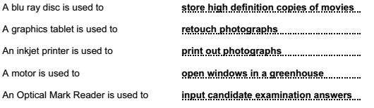

9. Explain why computer systems have both backing storage and RAM.
Three from:
- If computer is switched off work in RAM goes but backing storage stores data for future use
- More likely that data is accidentally deleted in RAM
- RAM is more expensive than backing storage per unit of memory
- RAM is bulkier than backing storage per unit of memory
- RAM provides faster access than backing storage
- Software package may be so large that it is physically impossible for RAM to store it.
- Data may need to be transferred from one computer to another and can’t do that with RAM

10. Draw four lines on the diagram to match the use to its most appropriate storage medium.
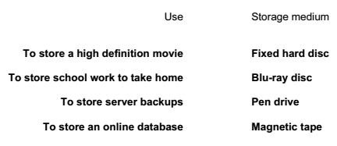
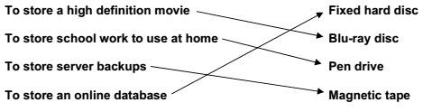

11. Complete each sentence below using one item from the list.
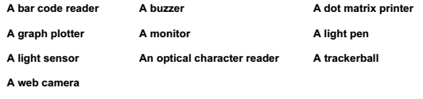
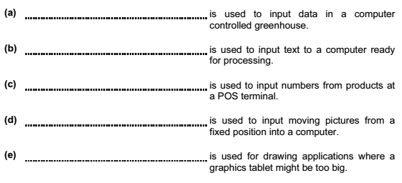
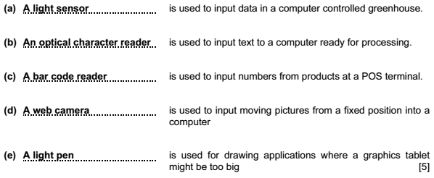

12. Complete each sentence below using one item from the list.
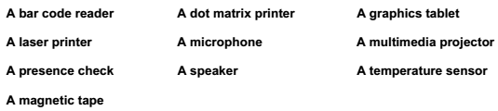
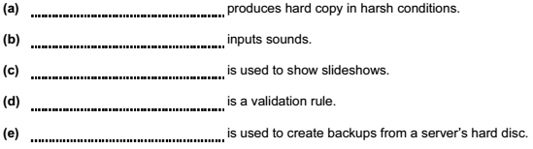

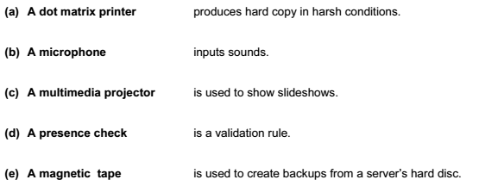

13. Describe the differences between RAM and ROM.
Four from:
- ROM cannot be changed/RAM can be changed
- RAM can be read from and written to
- ROM is read only memory and RAM is random access memory
- ROM holds instructions that need to be unchanged such as BIOS/program
- cycles in a washing machine/program instructions in games
- RAM holds the work that is being currently done by the user
- ROM is non-volatile/RAM is volatile
14. A student wishes to store data on an optical storage medium. List two optical media and give one advantage and one disadvantage of using optical media when compared with fixed hard discs.
Two devices from:
- CD
- DVD
- Blu-ray
- DVD RAM
One advantage from:
- More portable/less likely to spike/cheaper to buy
One disadvantage:
1. Limited capacity/slower access times/slower transfer rates/can be more easily
- lost/can be more easily stolen/can be more easily scratched

15. The main memory in computers is becoming very large. Give three reasons why backing storage is still needed.
Three from:
- Data in main memory can be lost if computer shuts down
- Data in main memory can be corrupted
- Data in main memory can be accidentally deleted
- Data/software may need to be switched from machine to machine 16.

16. Students can use CDs or pen drives for storing their work. Give three reasons why students may prefer to use pen drives.
Three from:
- Pen drives have greater storage capacity
- Pen drives are more portable
- Not all machines have CD drives
- Faster access to data
- More robust
- More secure as biometric data can be incorporated
- Don’t need specialist hardware/software for pen drives

17. Tick three reasons why optical media may be used to store data rather than magnetic media.
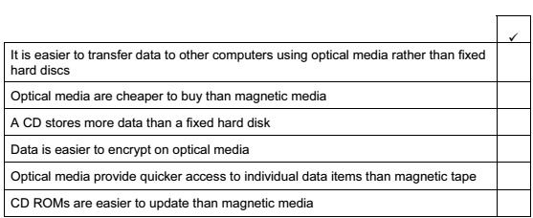
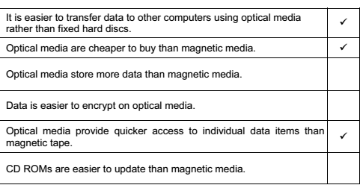
18. All computers come with main memory as well as backing storage. Give a reason why the following are needed.
RAM
ROM
Backing storage
RAM– So that users are able to make changes to the data they are working on/to store the program or data they are currently using
ROM– So that programs/coding/software can be stored permanently/cannot be changed
Backing storage– So that users can have a permanent copy of the work they are doing/can have a copy of their work when the computer is switched off

19. Most PCs come with a hard disc drive. Give a reason why each of the following are also used with PCs.
Magnetic tape: To make backups
CD R: To transfer data/programs from computer to computer/to save user data
DVD ROM: For companies to distribute software/movies/For users to install software/view multimedia

20. Explain why the following are used with PCs.
Pen drives
Blu-ray
Fixed hard disc drives

Pen drives - So that users can transfer data from one computer to another/to backup files/security dongle
Blu-ray- To enable large high definition/quality video files to be recorded
Fixed hard disc drives - So that users can have quick access to their data/software/so that software can be stored
21. RAM and ROM are types of storage.
Explain what RAM and ROM are used for.

ROM stores BIOS/program cycles in a washing machine/program instructions in games
RAM holds the data currently being used by the user

22. Michael wishes to make a copy of his Geography coursework which is stored on the school computer system. He wants to take it home to finish it for homework.
He can borrow a CD RW from school but he has a 128 Mb memory stick of his own.
- Give two advantages of using the CD RW.
- Give two advantages of using the memory stick.

- Two from:
- can store more data than the memory stick
- cheaper to replace (not just ‘cheaper’ on its own)
- not so easy to lose
- two from:
- more compact / easier to carry
- faster access to data
- faster data transfer
- more robust / difficult to damage
23. Complete the following sentences using the output devices listed below.
- A garage using multi-part stationery with carbon copies would need a
_____________________________________________________________________________________
- An architect’s office producing house plans using A0 size paper would use a
_____________________________________________________________________________________
- A student printing out coursework needing high quality printouts would use a
_____________________________________________________________________________________

- Dot matrix printer
- Graph plotter
- Laser printer

